WhatNext Vision Motors: Shaping the Future of Mobility with Innovation and Excellence

Use Case :
This TN Skills project is built in a Salesforce Developer Edition org. The screenshots show a Lightning app named WhatNext Vision Motors (description entered: "efficient delivering platform") that manages vehicle related data and automates routine steps around vehicle orders and test drives.
The project stores its data in custom objects: Vehicle, Vehicle Dealer, Vehicle Customer, Vehicle Order, Vehicle Test Drive and Vehicle Service Request. A Lightning app groups the tabs for these objects together with Reports and Dashboards, and is made available to the System Administrator profile.
Two record-triggered flows automate the process. The Auto Assign Dealer flow runs when a Vehicle Order is created, reads the customer's information, looks up a Vehicle Dealer by matching the dealer location with the customer's address, and updates the order with that dealer. The Test Drive Reminder flow runs on Vehicle Test Drive records and uses a scheduled path that fires one day before the test drive date to email the customer a reminder.
Apex code enforces and automates stock related behaviour for orders. A trigger on Vehicle Order calls the VehicleOrderTriggerHandler class, whose visible code includes a method to prevent placing an order if stock is zero. A batch class, VehicleOrderBatch, selects Vehicle Orders whose Status is Pending, and a scheduler class, VehicleOrderBatchScheduler, runs the batch with a batch size of 50. The job is scheduled daily as "Daily Vehicle Order Processing".

Requirements :

1. Salesforce Developer Edition Org
- Sign up for a Salesforce Developer Edition org, activate the account and log in to Setup.

2. Data Model (Custom Objects, Tabs and Fields)
- Create custom objects for vehicle, dealer, customer, order, test drive and service request data.
- Create custom tabs for the objects.
- Create fields on the Vehicle object: Vehicle Model (picklist), Stock Quantity (number) and a lookup relationship to the dealer.

3. Lightning App
- Create the WhatNext Vision Motors Lightning app with navigation items and user profile access.

4. Process Automation (Flows)
- Create a record-triggered flow, Auto Assign Dealer, that assigns a dealer to a newly created Vehicle Order.
- Create a record-triggered flow, Test Drive Reminder, with a scheduled path that sends a reminder email to the customer.

5. Apex and Trigger
- Write the VehicleOrderTriggerHandler Apex class and the VehicleOrderTrigger trigger on Vehicle Order.

6. Batch and Scheduled Apex
- Write the VehicleOrderBatch batch class and the VehicleOrderBatchScheduler schedulable class.
- Schedule the batch job and verify it under Scheduled Jobs.

What you'll learn :
- Developer org setup and account activation
- Data Modelling (custom objects)
- Custom Tabs
- Lightning App Builder / App Manager
- Fields and Relationships (picklist, number and lookup fields)
- Record-Triggered Flows (Get Records, Update Records, Scheduled Paths, Send Email action)
- Apex Classes and Apex Triggers using the Developer Console
- Batch Apex
- Scheduled Apex

MileStone 1 :

Activity 1: Creating Developer Account
Creating a developer org in Salesforce using the Developer Edition sign up page.
Step 1 : Open the Salesforce Developer Edition sign up page.
Step 2 : On the sign up form, enter the following details (as filled in the screenshot):
- First name and Last name
- Job title: Developer
- Company: college / organisation name
- Country/region: India
- Work email
- Tick the agreement check box
Step 3 : Click Sign me up.
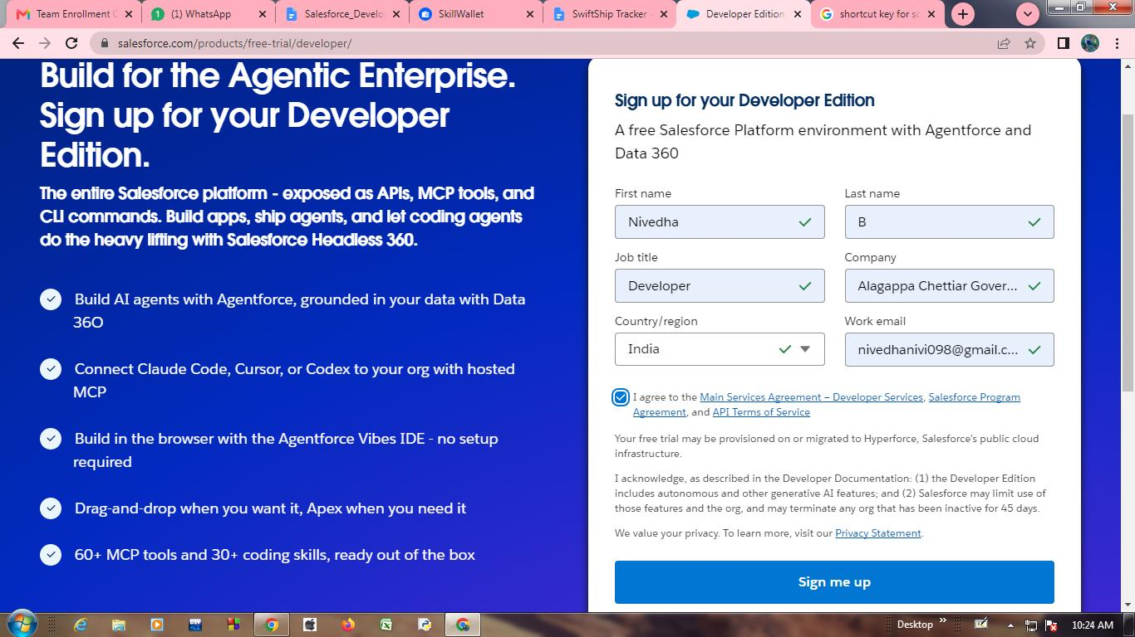
Figure 1: Sign up form for the Salesforce Developer Edition with the details filled in

Activity 2: Account Activation
Step 1 : Open the inbox of the email address used for sign up. The email "Welcome to Salesforce: Reset your password" contains a Reset Password button, the login URL of the org and the username. The email states the link expires in 24 hours.
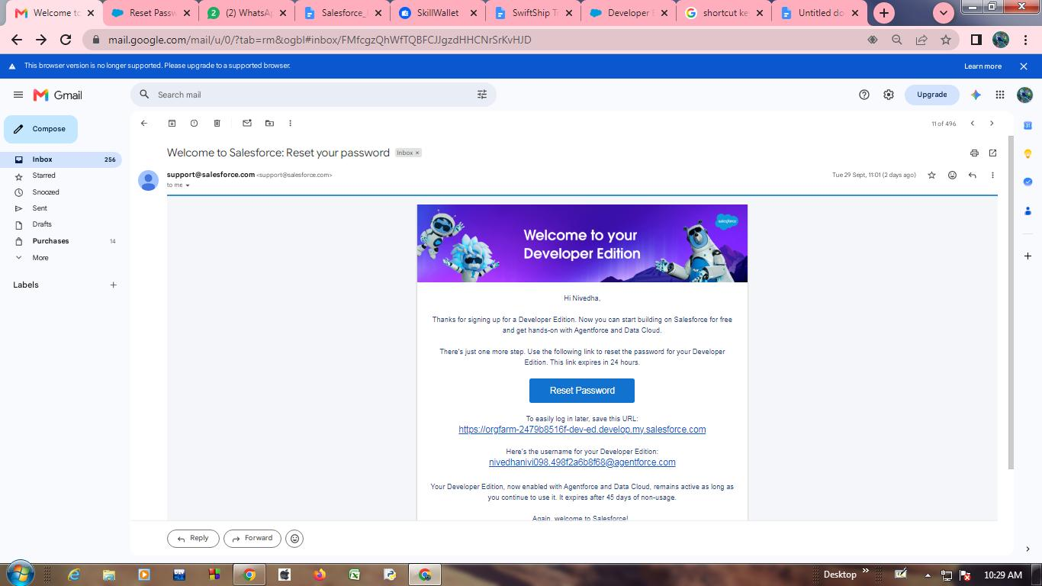
Figure 2: Welcome to your Developer Edition email with the Reset Password button
Step 2 : Click Reset Password and set the password. On first login from the new org, Salesforce asks for identity verification: enter the verification code emailed to you and click Verify. The Don't ask again check box is ticked.
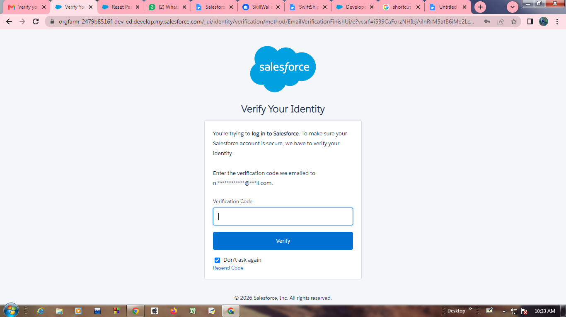
Figure 3: Verify Your Identity page asking for the emailed verification code
Step 3 : After verification you are redirected to the Salesforce Setup Home page, which greets the user with "Welcome, Nivedha".
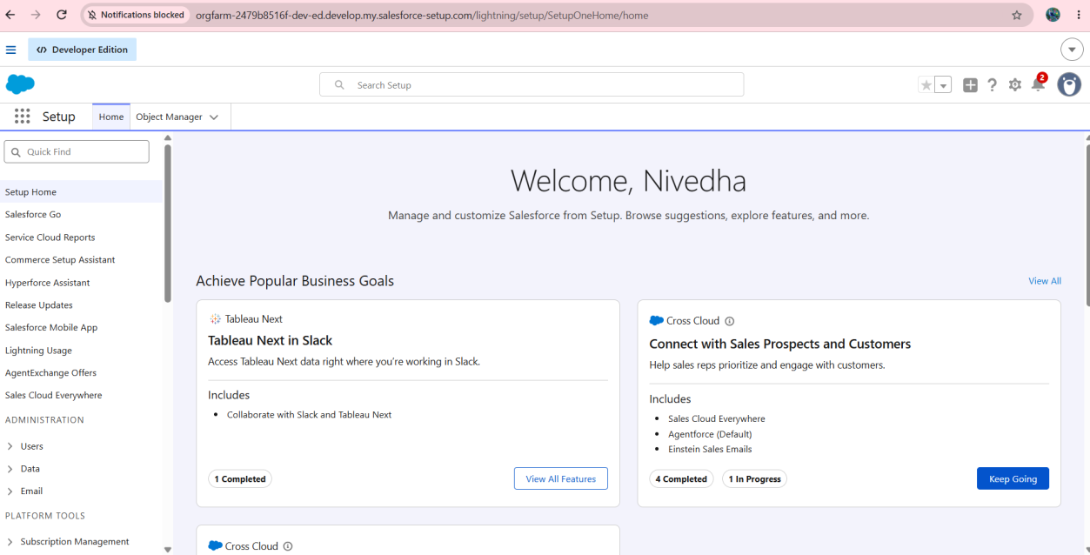
Figure 4: Salesforce Setup Home page after successful login

MileStone 2 :

Objects & Relationships
The Object Manager and the custom tabs in the screenshots show six custom objects. The table lists what the screenshots show for each of them.
Object Name | What the screenshots show | Relationships shown
Vehicle (Vehicle__c) | Created in Activity 1. Fields shown: Vehicle Model (picklist), Stock Quantity (number), Vehicle Dealer (lookup). | Lookup to Vehicle Dealer. Referenced from Vehicle Order.
Vehicle Dealer (Vehicle_Dealer__c) | Has a tab. Dealer Location field is used in the Auto Assign Dealer flow. | Selected as Assigned Dealer on Vehicle Order.
Vehicle Customer (Vehicle_Customer__c) | Has a tab. Its Address and Email values are used in the flows. | Referenced from Vehicle Order through the Vehicle Customer field.
Vehicle Order (Vehicle_Order__c) | Fields shown: Vehicle Order Number, Vehicle Customer, Vehicle, Order Date, Status, Assigned Dealer. | Related to Vehicle Customer, Vehicle and Vehicle Dealer.
Vehicle Test Drive (Vehicle_Test_Drive__c) | Has a tab. Test Drive Date is used as the time source of the scheduled path. | Customer information is read in the Test Drive Reminder flow.
Vehicle Service Request | Has a tab only. | [Information not available in the provided screenshots]

To Navigate to Setup page:
Click on the gear icon, then click Setup. The Setup Menu also lists Data Cloud Setup, Salesforce Go, Agentforce Vibes and Developer Console.
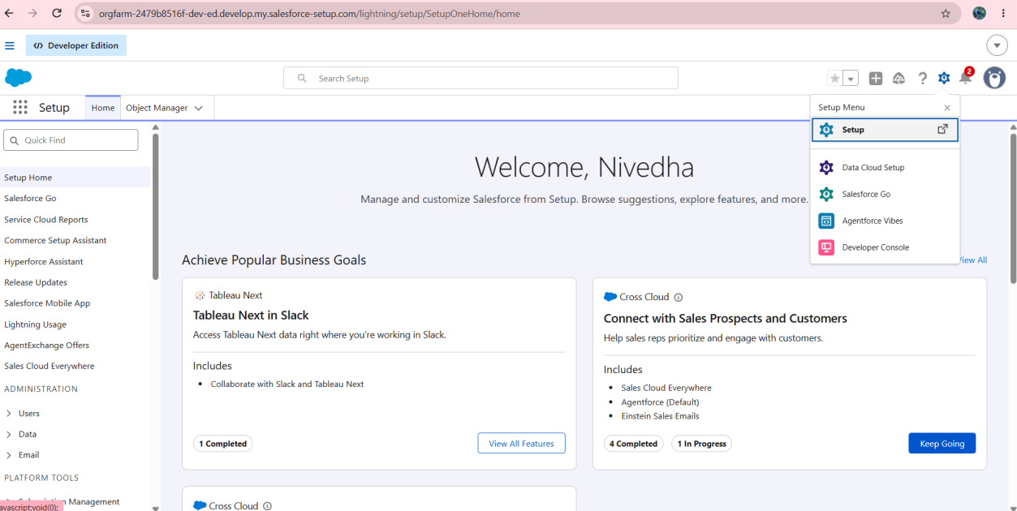
Figure 5: Setup Menu opened from the gear icon on the Setup Home page

Activity 1: Create Vehicle Object
The purpose of creating a Vehicle custom object is to store the vehicle details.
To create an object:
Step 1 : From the Setup page, click Object Manager. The Object Manager lists the standard objects of the org.
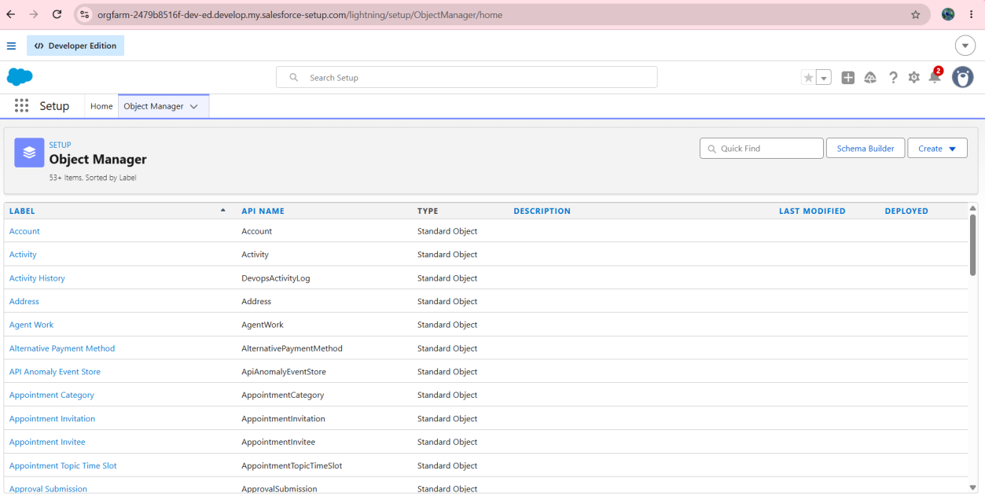
Figure 6: Object Manager listing the standard objects of the org
Step 2 : Click Create and select Custom Object.
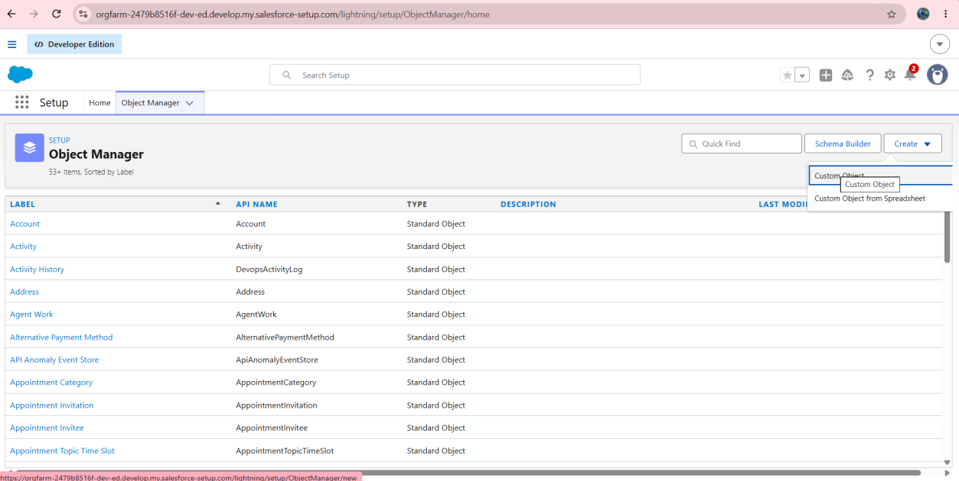
Figure 7: Create drop-down in Object Manager with the Custom Object option
Step 3 : On the New Custom Object page enter the following:
- Label: Vehicle
- Plural Label: Vehicles
- Object Name: Vehicle
- Record Name: Vehicle Name
- Data Type: Text
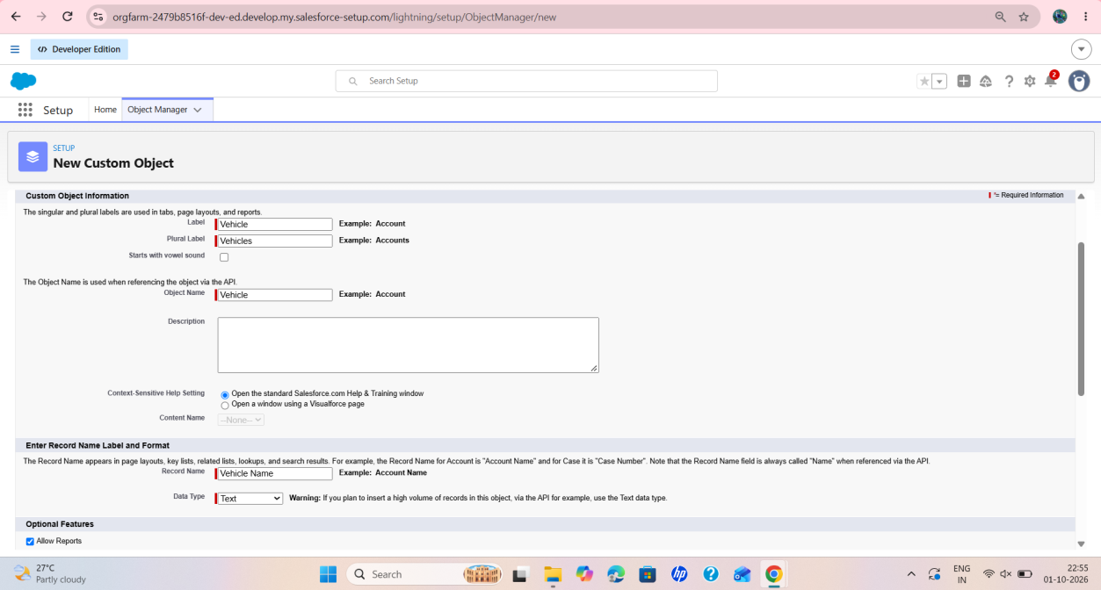
Figure 8: New Custom Object form with Label, Plural Label, Object Name and Record Name filled in
Step 4 : Scroll down and check Allow Reports. Under Deployment Status the Deployed option is selected, and Allow Search is checked. Click Save.
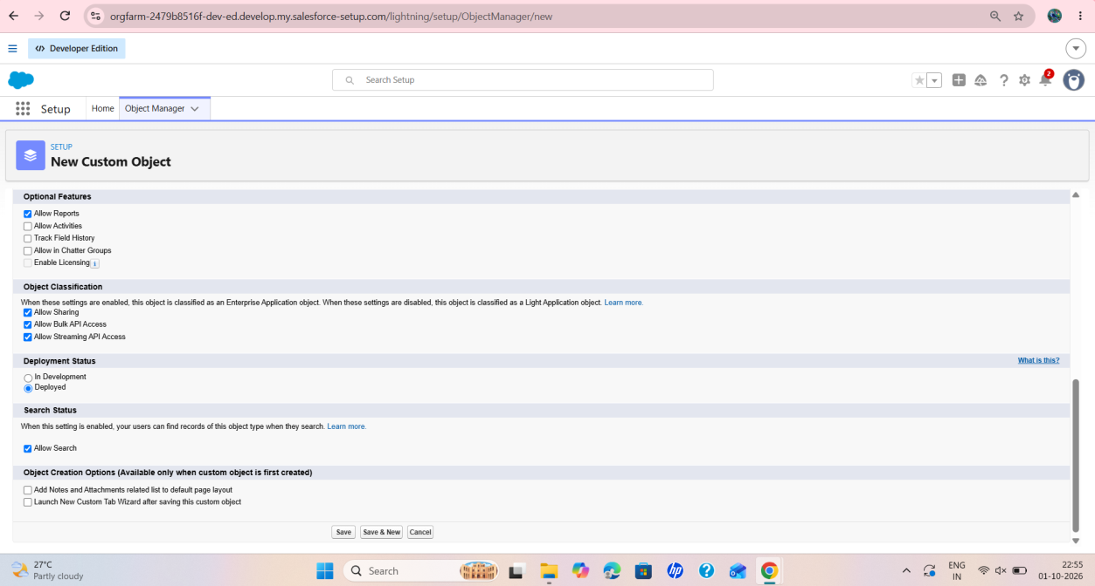
Figure 9: Optional Features, Deployment Status and Search Status settings of the new Vehicle object

Activity 2: Creating remaining objects

Plural Label | Object Name (API name) | Record Name | Data Type
Vehicle Dealer | Vehicle Dealers | Vehicle_Dealer (Vehicle_Dealer__c) | Dealer Name | Text
Vehicle Customer | Vehicle Customers | Vehicle_Customer (Vehicle_Customer__c) | Customer Name | Text
Vehicle Order | Vehicle Orders | Vehicle_Order (Vehicle_Order__c) | Vehicle Order Number | Auto Number (O-{0000})
Vehicle Test Drive | Vehicle Test Drives | Vehicle_Test_Drive (Vehicle_Test_Drive__c) | Test Drive Name | Text
Vehicle Service Request | Vehicle Service Requests | Vehicle_Service_Request (Vehicle_Service_Request__c) | Service Request Name | Text

Milestone 3 - Tabs

Activity 1: Creating Custom Tabs
Step 1 : Go to the Setup page, type Tabs in the Quick Find bar and click Tabs. The Custom Object Tabs section lists the tabs created for the objects: Vehicle Customers, Vehicle Dealers, Vehicle Orders, Vehicles, Vehicle Service Requests and Vehicle Test Drives.
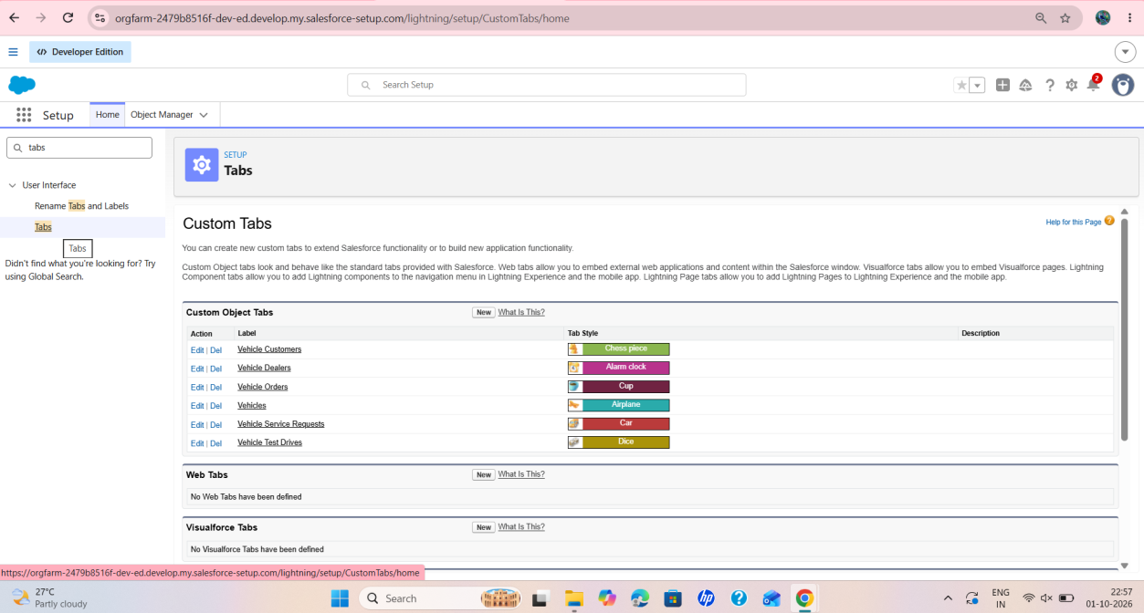
Figure 10: Custom Tabs page listing the six Vehicle custom object tabs

Activity 2: Edit the Vehicles Tab
Step 1 : Open the Vehicles tab to view its definition. The Custom Object Tab Information shows Tab Label: Vehicles, Object: Vehicle and Tab Style: Airplane. Splash Page Custom Link is None. Click Save.
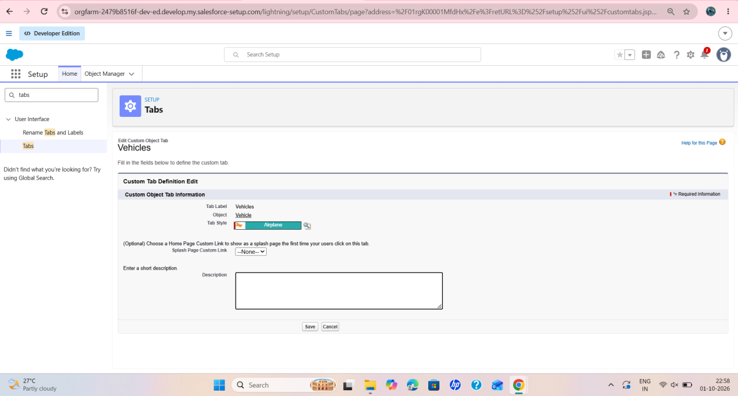
Figure 11: Custom Tab Definition Edit page of the Vehicles tab

Milestone 4- The Lightning App:

Activity 1: Create a Lightning App
To create a Lightning app:
Step 1 : Go to the Setup page, search "app manager" in Quick Find, select App Manager and click New Lightning App.
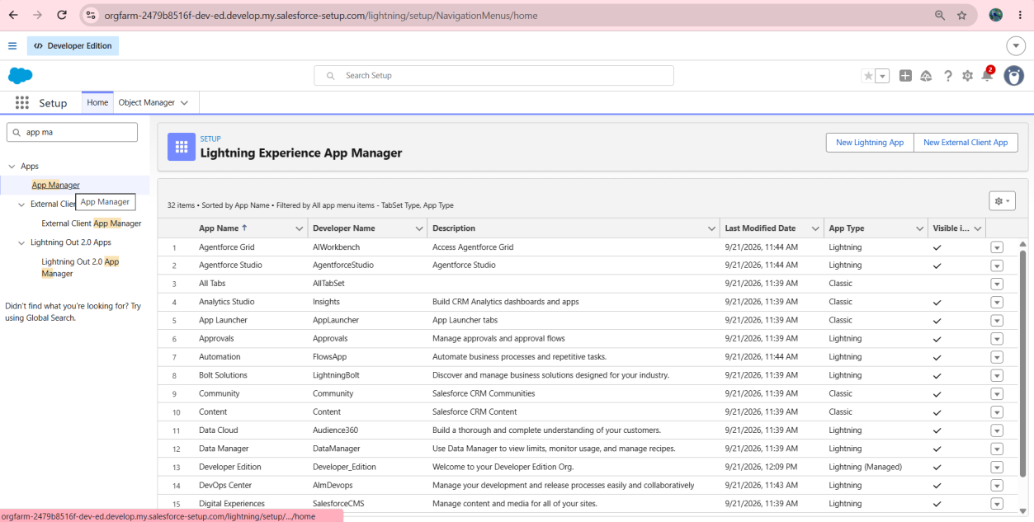
Figure 12: Lightning Experience App Manager listing the apps of the org
Step 2 : Fill in App Details & Branding as follows:
- App Name: WhatNext Vision Motors
- Developer Name: auto populated (the screenshot shows the text "this will auto populated" entered)
- Description: efficient delivering platform
- Primary Color Hex Value: #0070D2 (default)
Click Next.
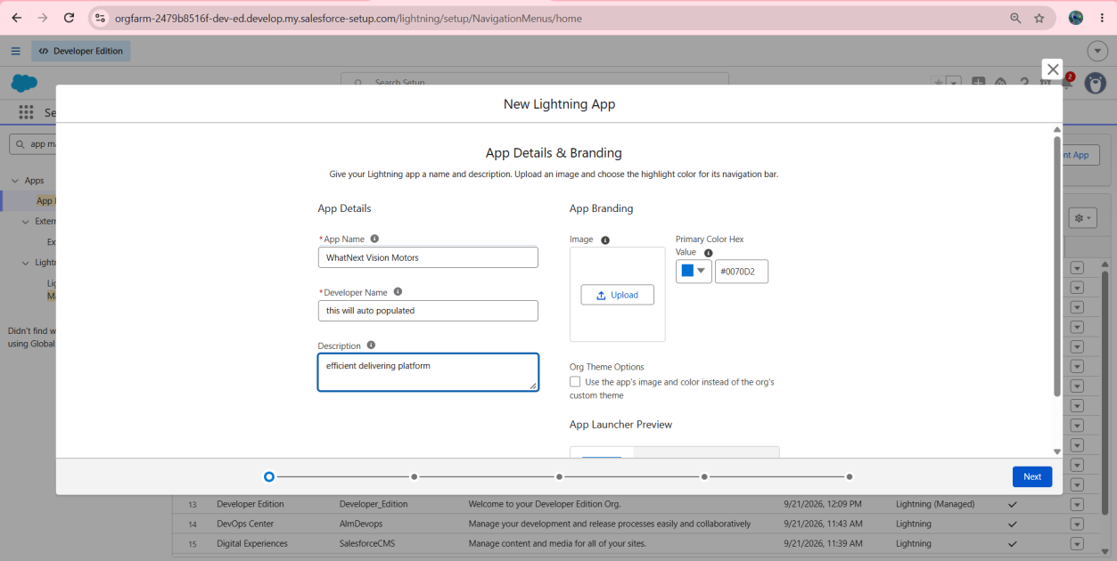
Figure 13: New Lightning App wizard with the App Details and Branding entered
Step 3 : Add the Navigation Items. In the screenshot the Selected Items are Vehicles, Vehicle Dealers, Vehicle Customers, Vehicle Orders, Vehicle Service Requests, Vehicle Test Drives, Reports and Dashboards. The custom objects are searched in the Available Items list and moved with the arrow button.
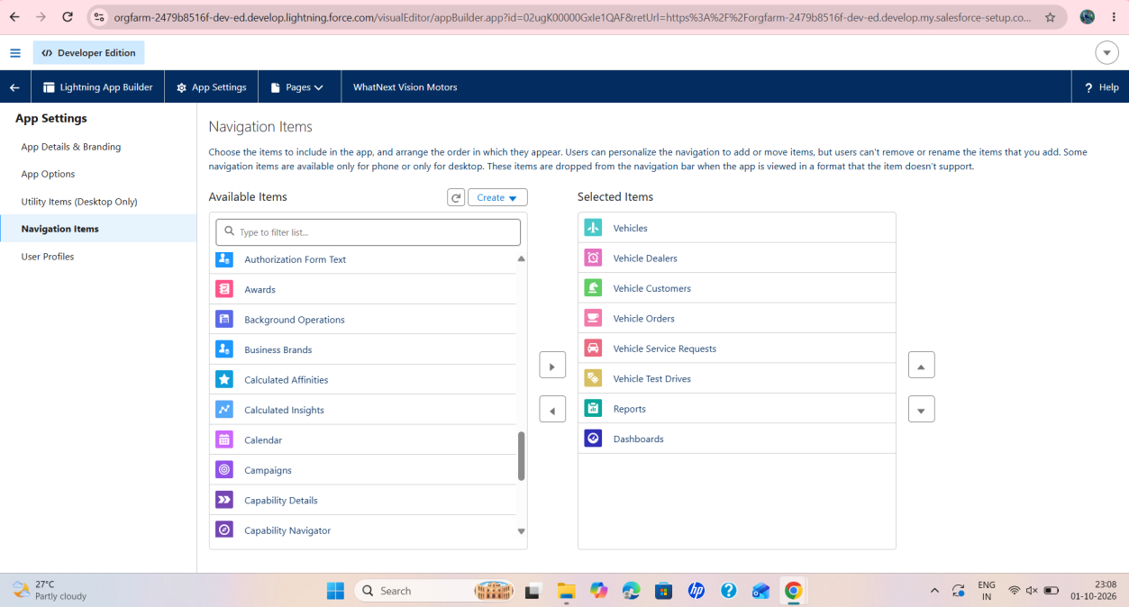
Figure 14: Navigation Items of the WhatNext Vision Motors app with the selected items
Step 4 : Add the User Profiles. System Administrator is moved to Selected Profiles.
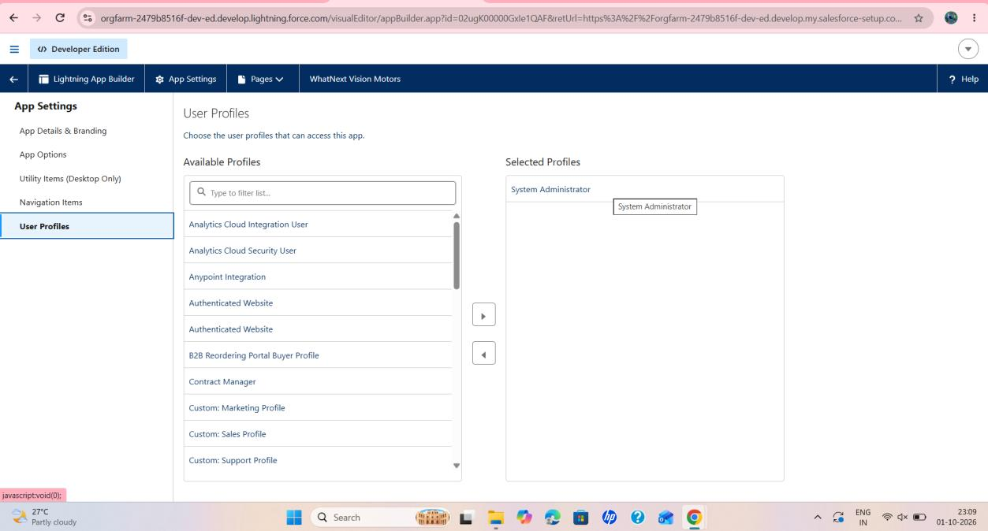
Figure 15: User Profiles page with System Administrator selected for the app
Step 5 : Verify the object in Object Manager. Searching "vehicle" shows the Vehicle object (API name Vehicle__c, type Custom Object, Deployed).
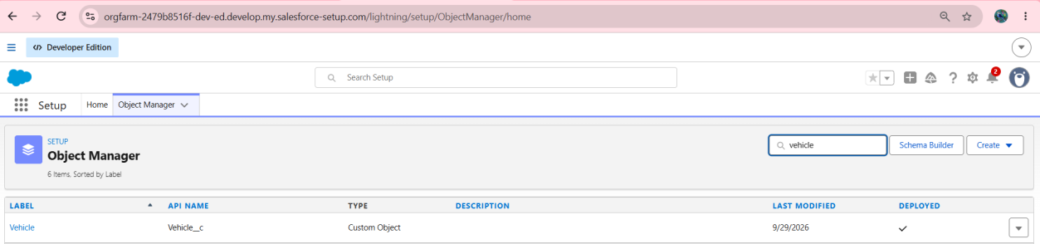
Figure 16: Object Manager search result showing the Vehicle custom object

Milestone 5 : Fields & Relationships
Fields are created in the Vehicle object from Setup, Object Manager, Vehicle, Fields & Relationships, New. The screenshots show the Vehicle Model picklist, the Stock Quantity number field and a lookup relationship to the dealer. The field list of the Vehicle object is shown in Figure 44 (Milestone 7). It contains Vehicle Dealer (Lookup), Vehicle Model (Picklist) and Vehicle Name (Text(80)).

Activity 1: Creating a Field in Vehicle Object (Vehicle Model)
Step 1 : Choose the field type. Select Data Type as Picklist and click Next.
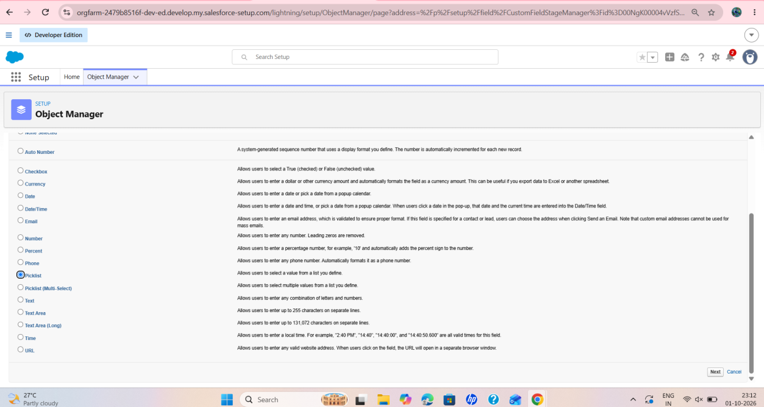
Figure 17: New Custom Field wizard with the Picklist data type selected

Step 2 : Enter the details. Field Label: Vehicle Model. The picklist values entered are Sedan, SUV, EV and etd. The Field Name is Vehicle_Model. Click Next and then Save.
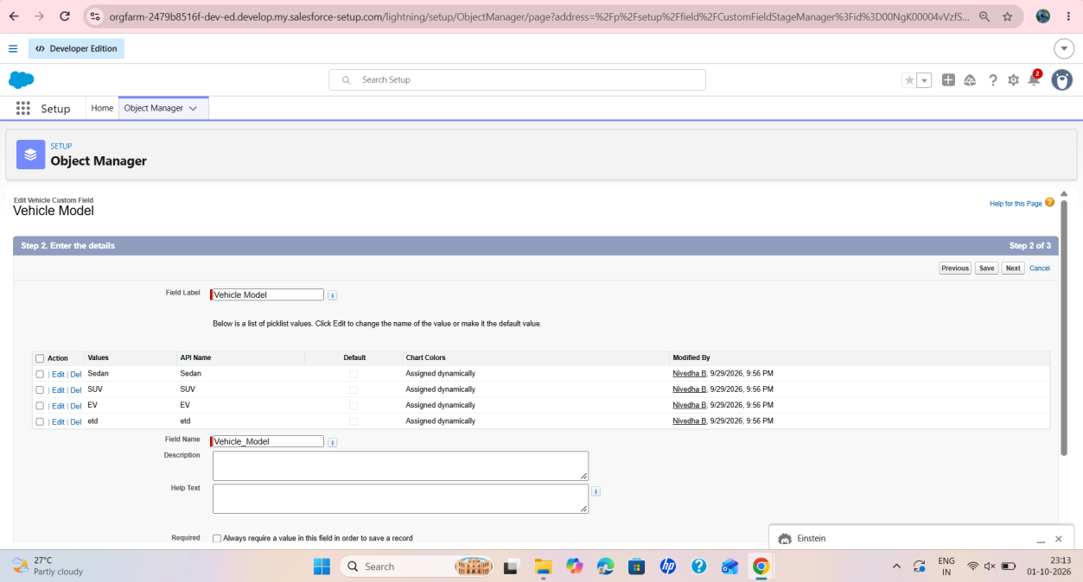
Figure 18: Vehicle Model picklist field with its values and field name

Activity 2: Creating Stock Quantity field in Vehicle Object
Step 1 : Repeat the field creation steps. Select Data Type as Number and click Next.
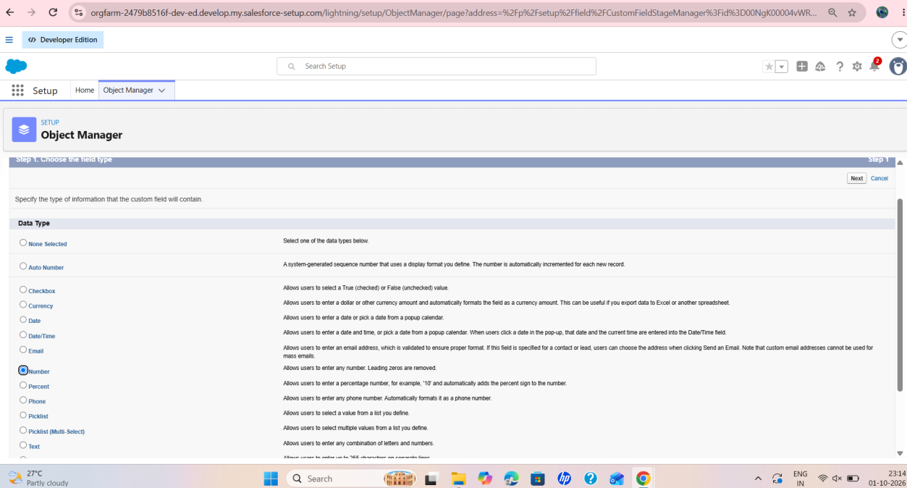
Figure 19: New Custom Field wizard with the Number data type selected
Step 2 : Enter Field Label: Stock Quantity, Length: 18 and Decimal Places: 0. The Field Name is Stock_Quantity. Click Next and then Save.
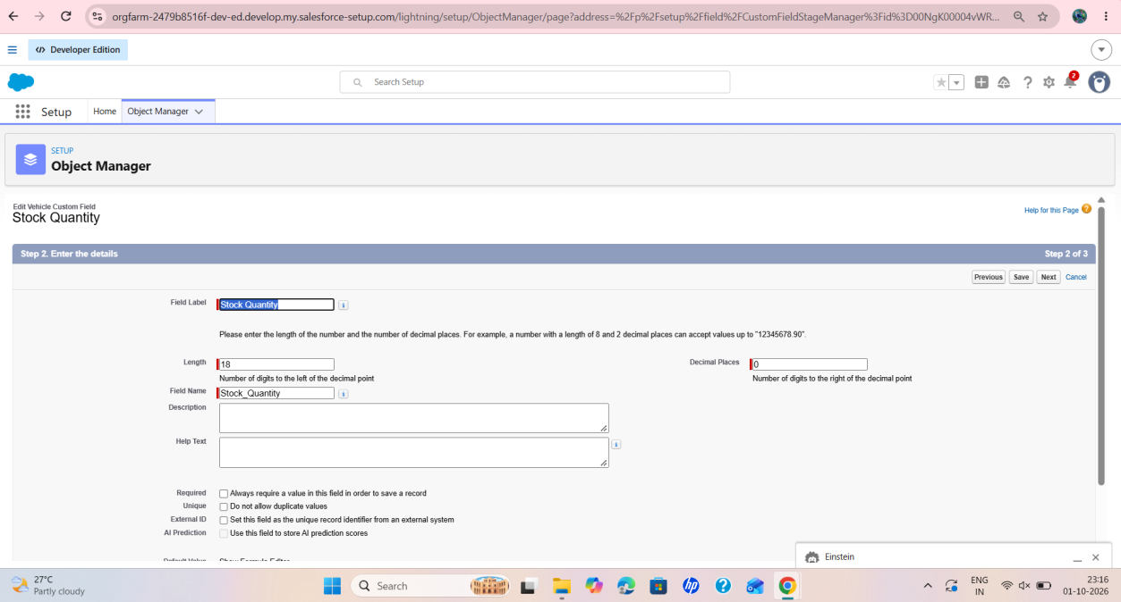
Figure 20: Stock Quantity number field with length 18 and 0 decimal places

Activity 3: Creating a Lookup Relationship in Vehicle Object to Dealer Object
Step 1 : Select Data Type as Lookup Relationship and click Next.
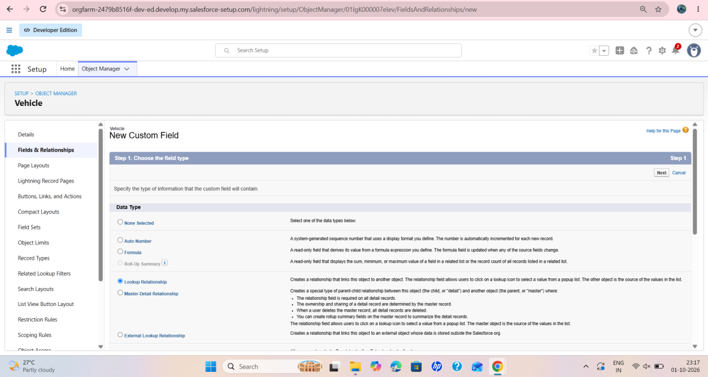
Figure 21: New Custom Field wizard with Lookup Relationship selected on the Vehicle object
Step 2 : In the step "Choose the related object" the dealer object is selected. This screen: [Information not available in the provided screenshots].

Step 3 : The label and name entered for the lookup field are both Dealer (Data Type: Lookup). In Step 4 of the wizard, field-level security is shown with the Visible check box ticked for the listed profiles. Click Next and Save.
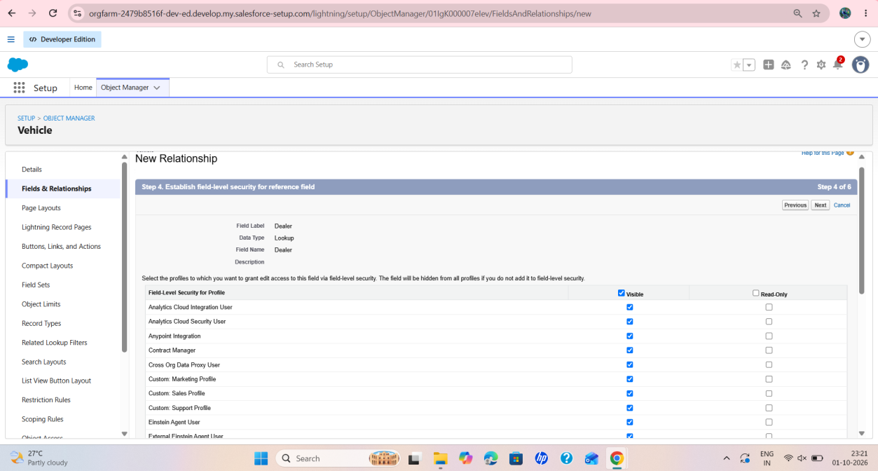
Figure 22: Step 4 of the New Relationship wizard establishing field-level security for the Dealer lookup field

Activity 4: Creating Remaining Objects and Fields
Screenshots of the fields of Vehicle Dealer, Vehicle Customer, Vehicle Order, Vehicle Test Drive and Vehicle Service Request:

MileStone 6 :

Flow 1 : Creating a record triggered flow to assign the nearest dealer to the customer's location
Step 1 : In Quick Find, type Flows and click Flows. The Flows page lists the flows of the org. The Auto Assign Dealer flow (Autolaunched Flow, Active, Unmanaged) is visible in the list. Click New Flow.
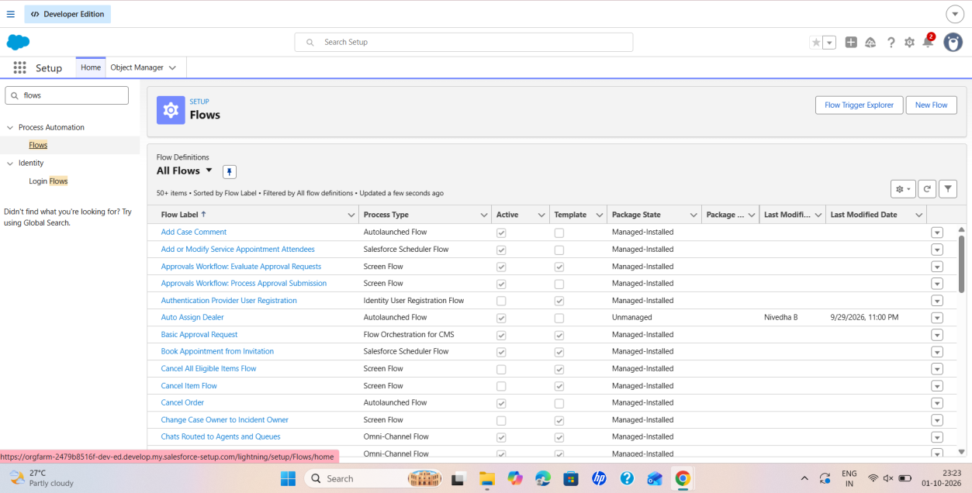
Figure 23: Flows page listing flow definitions, including Auto Assign Dealer

Step 2 : In the New Automation window, choose the category Triggered Automations and select Record-Triggered Flow from the Frequently Used section.
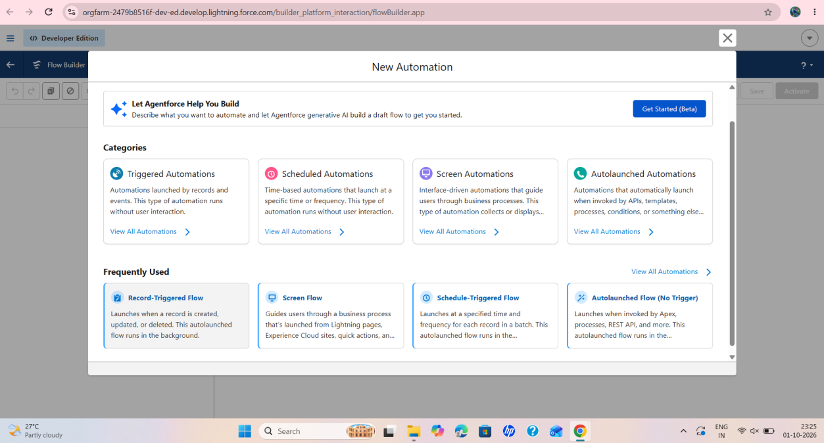
Figure 24: New Automation window in Flow Builder showing categories and frequently used flow types

Step 3 : Configure Start. Select the object Vehicle Order. Under Configure Trigger, select "A record is created". Under Set Entry Conditions, Condition Requirements is All Conditions Are Met (AND).
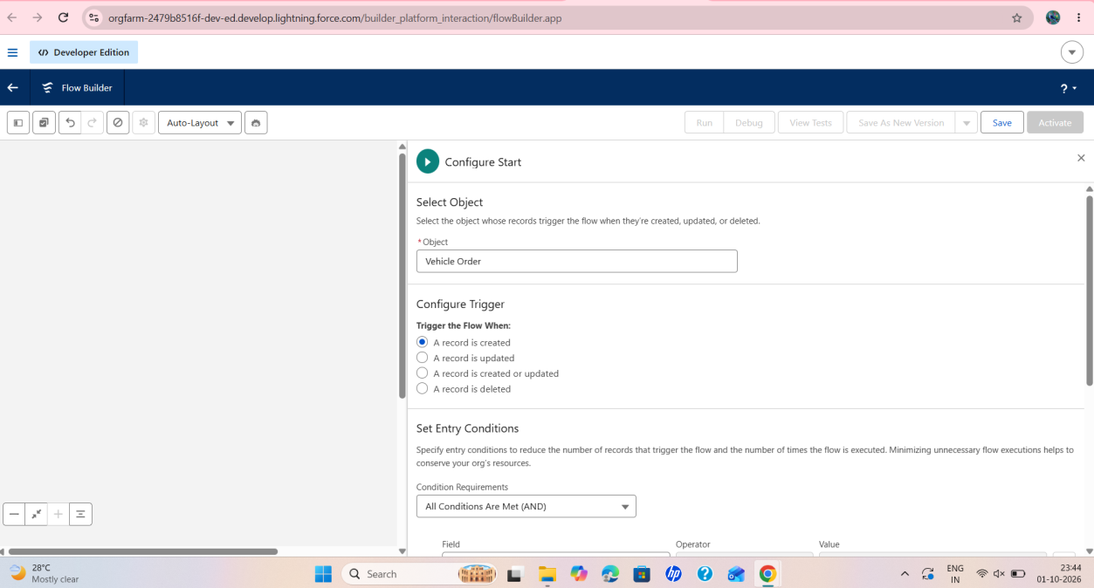
Figure 25: Configure Start panel with Vehicle Order object and the record-created trigger
Step 4 : The flow is saved as Auto Assign Dealer (Version 1). The Start element shows Object: Vehicle Order, Trigger: A record is created, Conditions: 1 and Optimize for: Actions and Related Records. Elements follow the Run Immediately path.
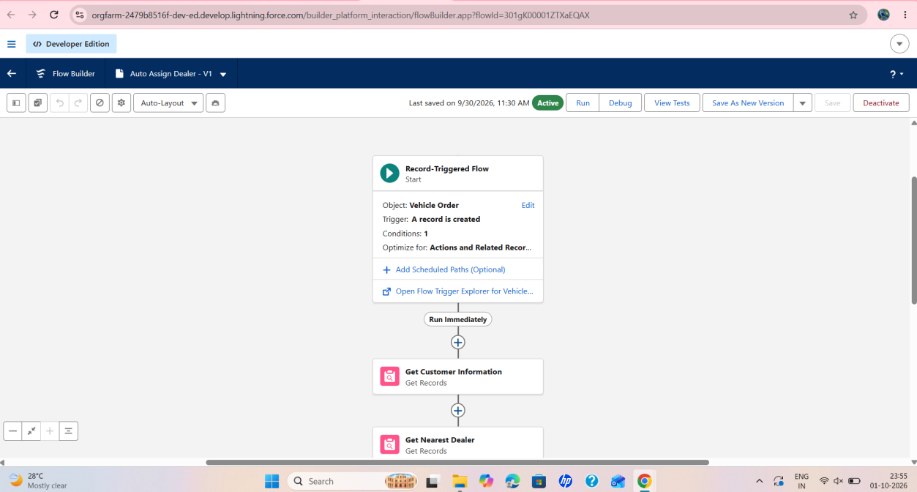
Figure 26: Auto Assign Dealer flow canvas with the Start element and the first Get Records elements
Step 5 : Click + and select Get Records. Label: Get Customer Information (API Name Get_Customer_Information). Object: Vehicle Customer. Condition: Field Record ID, Operator Equals, Value from the Vehicle Order's Vehicle Customer field.
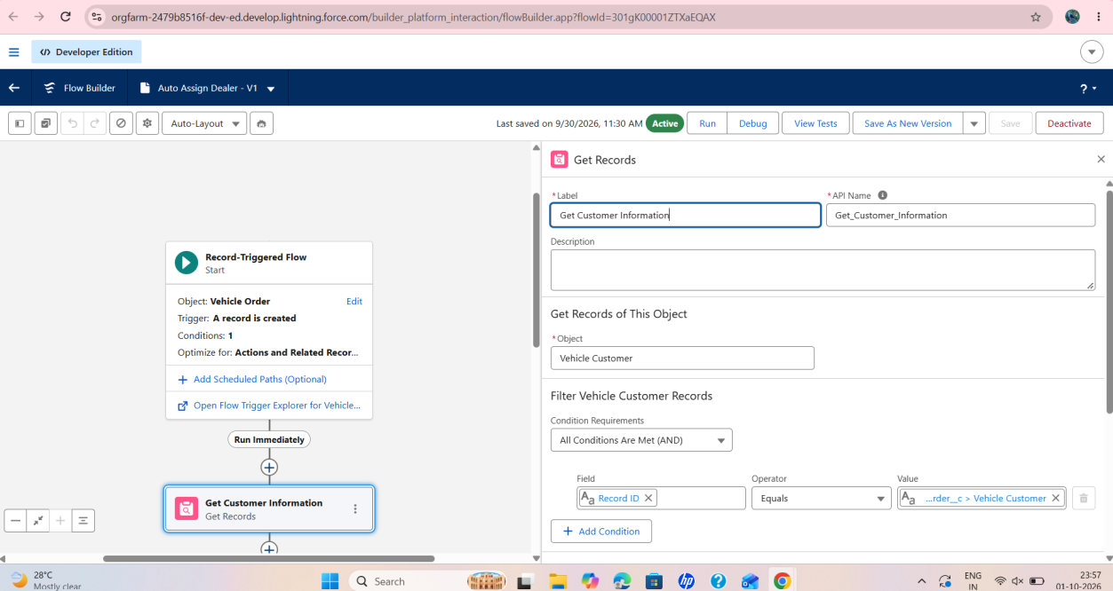
Figure 27: Get Records element Get Customer Information filtering Vehicle Customer records

Step 6 : Click + and select Get Records. Label: Get Nearest Dealer (API Name Get_Nearest_Dealer). Object: Vehicle Dealer. Condition: Field Dealer Location, Operator Equals, Value is the Address from Get Customer Information.
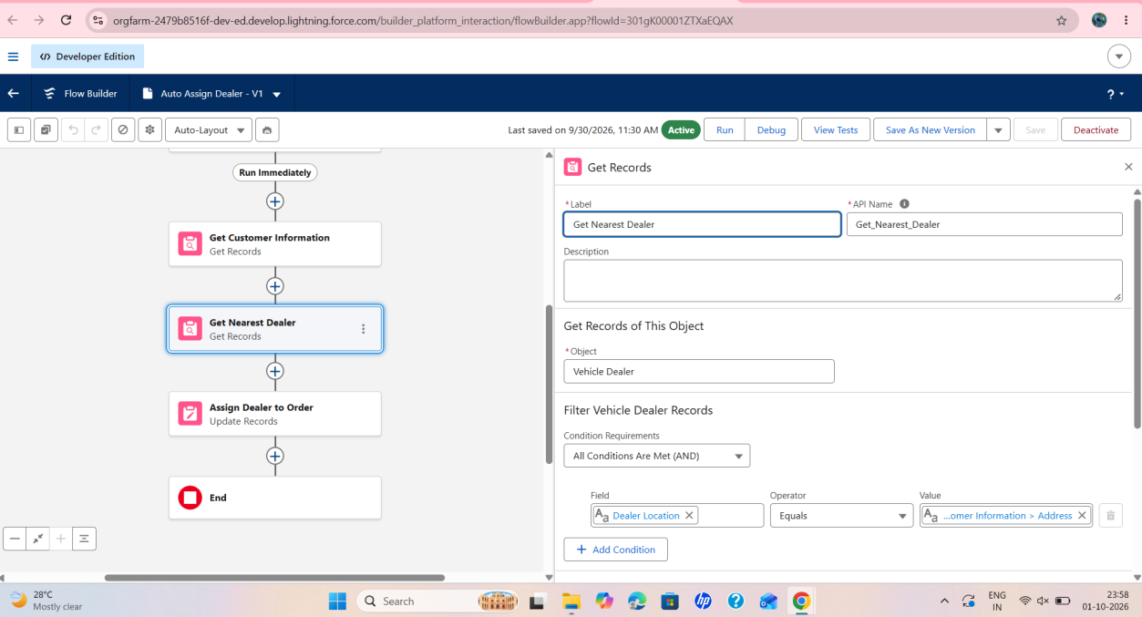
Figure 28: Get Records element Get Nearest Dealer filtering Vehicle Dealer records by Dealer Location
Step 7 : Click + and select Update Records. Label: Assign Dealer to Order (API Name Assign_Dealer_to_Order). The option "Specify conditions to identify records, and set fields individually" is selected, and the object is Vehicle Order.
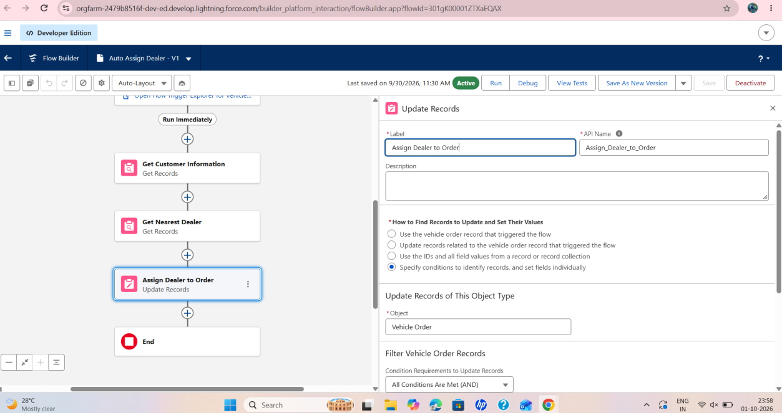
Figure 29: Update Records element Assign Dealer to Order
Step 8 : The completed flow runs Start, Get Customer Information, Get Nearest Dealer, Assign Dealer to Order and End. The flow status is Active.
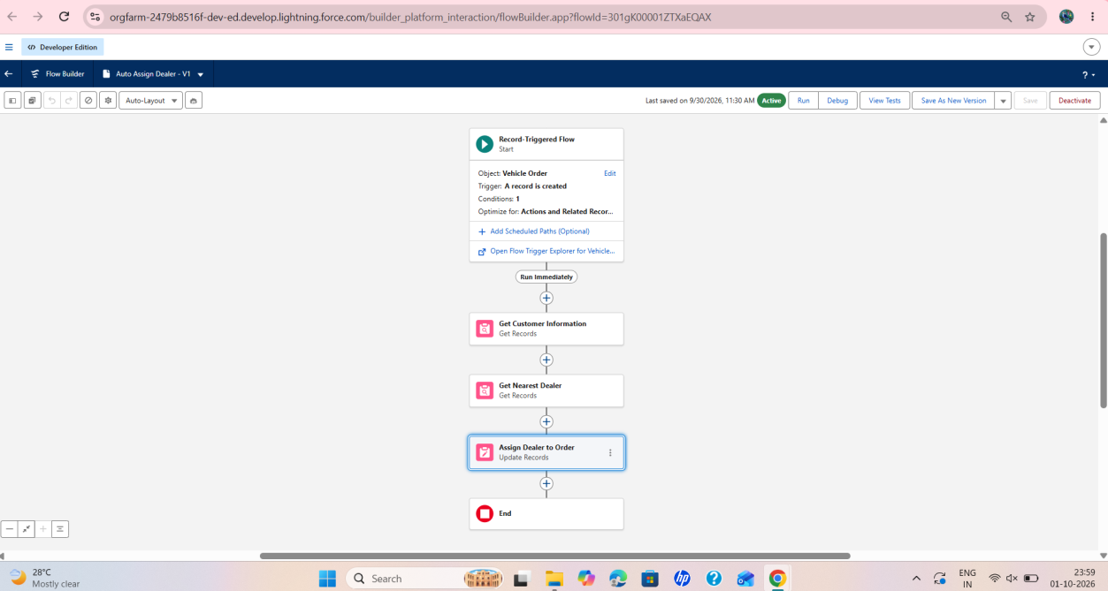
Figure 30: Completed Auto Assign Dealer flow with Active status

Flow 2 : Creating record triggered flow to send an email to the customer reminding about the test drive
Step 1 : Open Flow Builder and click New Flow. In the New Automation window select Record-Triggered Flow.
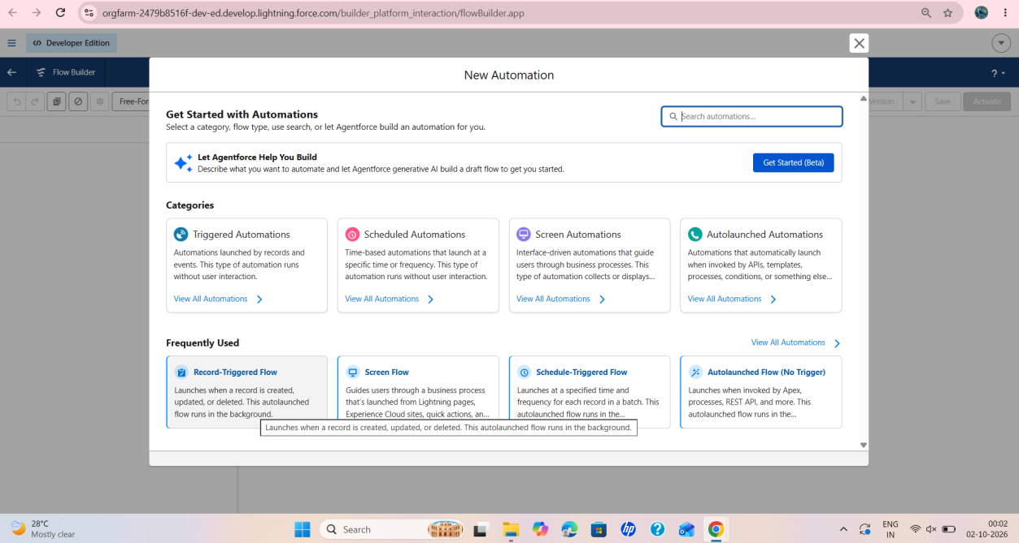
Figure 31: New Automation window opened to create the Test Drive Reminder flow
Step 2 : The Start element of the flow shows Object: Vehicle Test Drive, Trigger: A record is created or updated, Conditions: 2 and Scheduled Paths: 2. The option Add Scheduled Paths (Optional) in the Start element is used to add the scheduled path.
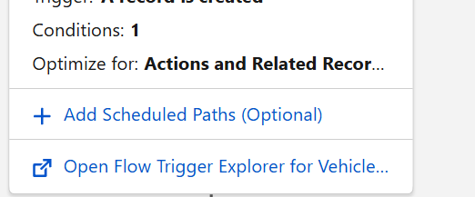
Figure 32: Start element options including Add Scheduled Paths (Optional)
Step 3 : Configure Scheduled Paths. Path Label: Reminder Before Test Drive (API Name Reminder_Before_Test_Drive). Time Source: Vehicle_Test_Drive__c: Test Drive Date. Offset Number: 1. Offset Options: Days Before. The flow canvas shows two paths, Run Immediately (End) and Reminder Before Test Drive.
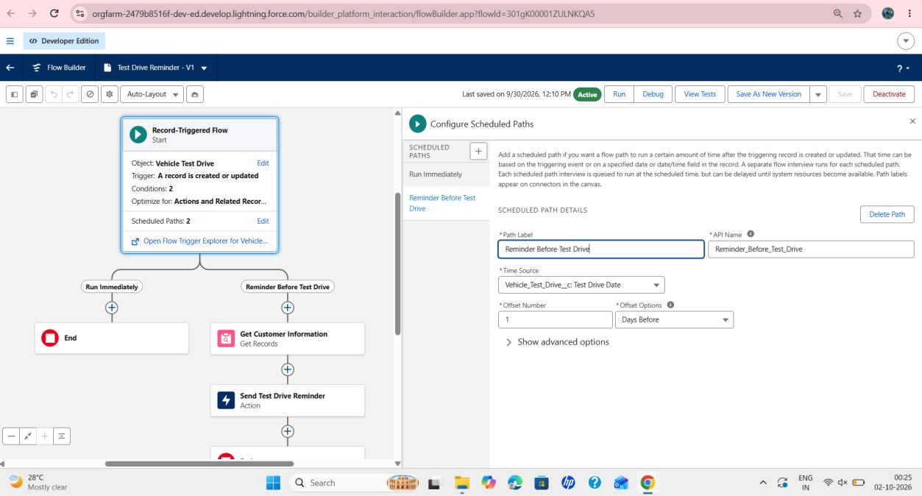
Figure 33: Test Drive Reminder flow with the Reminder Before Test Drive scheduled path configuration
Step 4 : Add the Get Customer Information element on the Reminder Before Test Drive path. The screenshots show Flow Builder's element-selection mode, where elements can be selected and copied, on the Auto Assign Dealer flow. The same flow canvas displays the Run Immediately path and the Reminder Before Test Drive path.
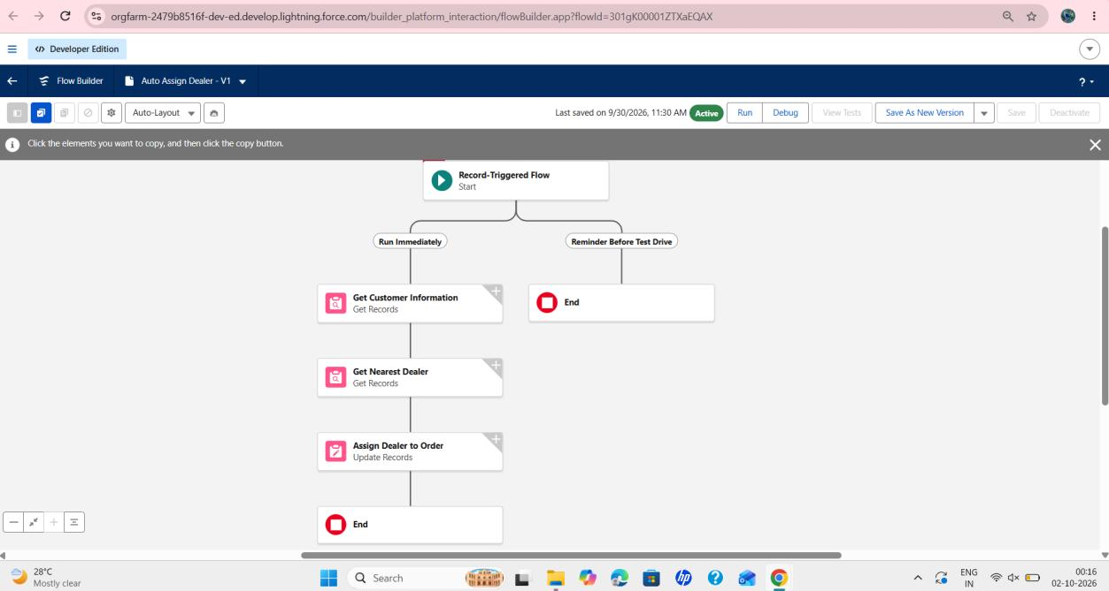
Figure 34: Flow Builder element-selection (copy) mode showing the Run Immediately and Reminder Before Test Drive paths
Step 5 : The Toolbox lists the resources and elements of the flow: Get Records (2) and Update Records (1), and the record variables from Get Customer Information and Get Nearest Dealer. The Get Customer Information element (Object Vehicle Customer, Condition Record ID Equals the Vehicle Customer of the order) is selected.
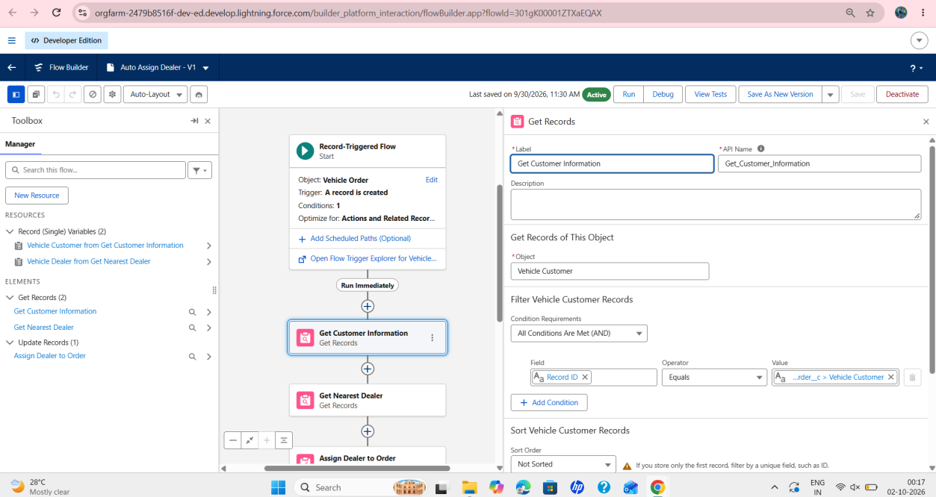
Figure 35: Toolbox and Get Customer Information element configuration

Step 6 : Add the action element to send the reminder. Click + on the scheduled path, select Action and choose Send Email. Label: Send Test Drive Reminder (API Name Send_Test_Drive_Reminder). Under Configure Recipient Details, Recipient Address is the Email of the Vehicle Customer from Get Customer Information.
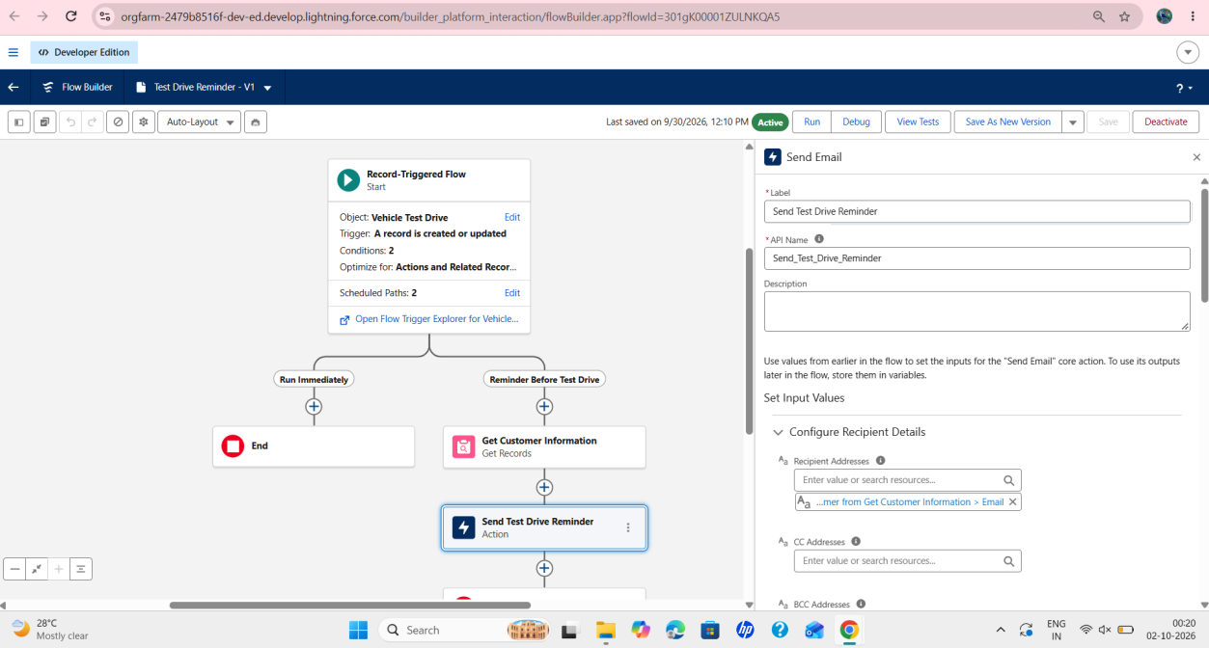
Figure 36: Send Email action Send Test Drive Reminder with the recipient address from Get Customer Information

Step 7 : Compose the email. Select Compose Email Content. Subject: "Reminder: Your Test Drive is Tomorrow!". The body entered in the editor is shown below.

Dear User{!Get_Customer_Information.Name},
This is a remainder that your test drive {!$Record.Id} is tommorow.if you need to reschedule please contact us at support@gmail.com
thank you

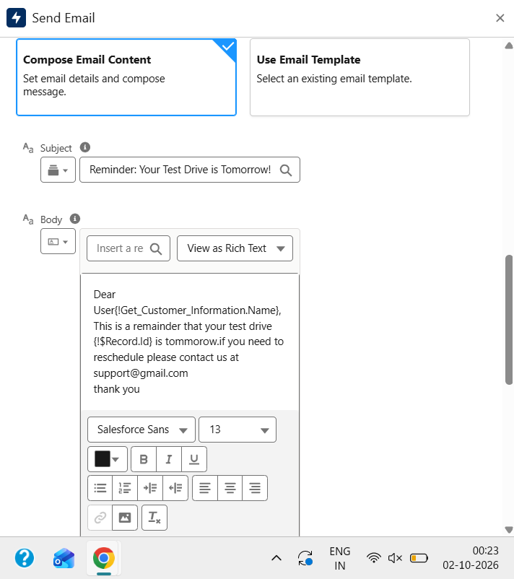
Figure 37: Compose Email Content with the subject and body of the test drive reminder

Step 8 : Further settings of the Send Email action: Rich-Text-Formatted Body is True and Use Line Breaks is True. Attachment ID, Attachment ID Collection, Recipient ID and Related Record ID are left empty.
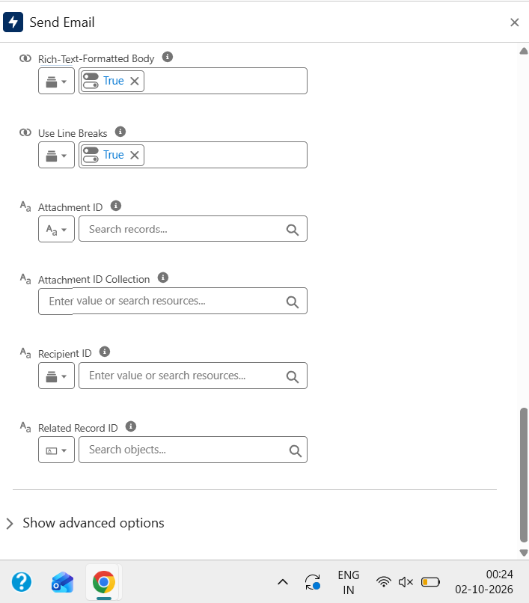
Figure 38: Send Email settings with Rich-Text-Formatted Body and Use Line Breaks set to True
Step 9 : Click Save and choose "A New Version". The Flow Label is Test Drive Reminder (Flow API Name Test_Drive_Reminder). The flow was first active as Version 1 and is saved here as a new version.
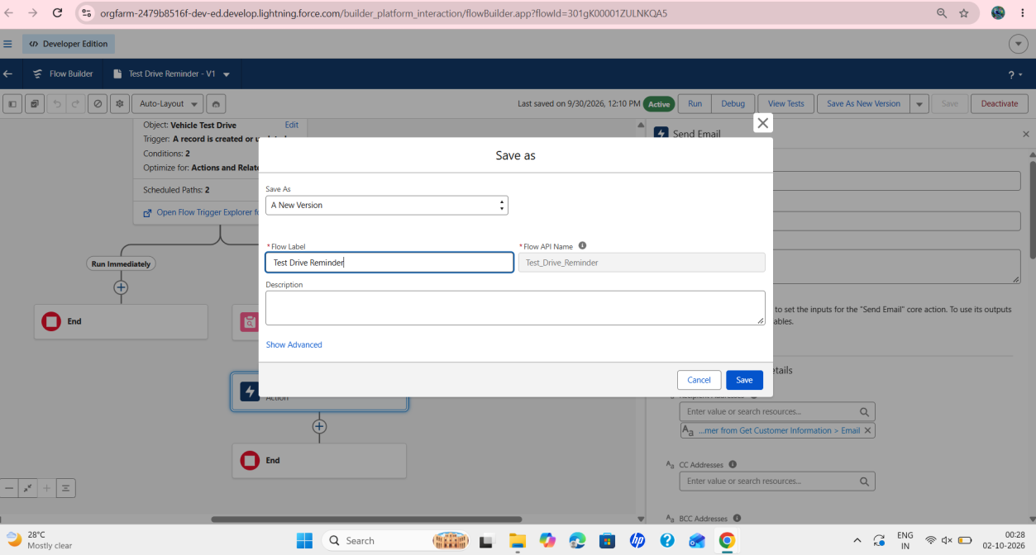
Figure 39: Save as dialog creating a new version of the Test Drive Reminder flow
Step 10 : Version 2 of Test Drive Reminder is saved and shows the Inactive status with the Activate button available.
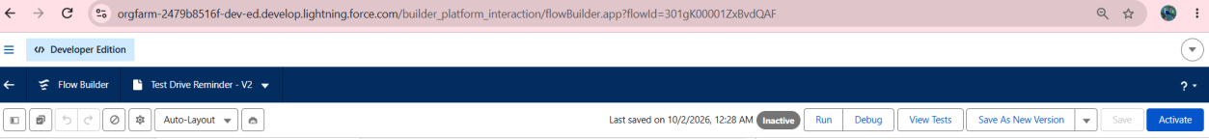
Figure 40: Test Drive Reminder Version 2 in Inactive status with the Activate button
Step 11 : Click Activate. Version 2 becomes Active. The flow canvas shows Start, the Run Immediately path ending at End, and the Reminder Before Test Drive path with Get Customer Information, Send Test Drive Reminder and End.
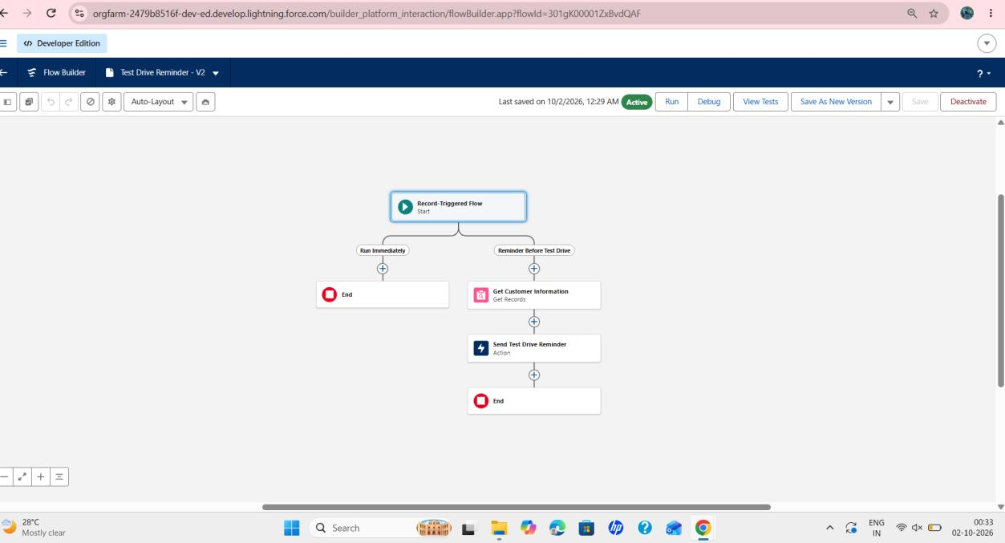
Figure 41: Test Drive Reminder Version 2 in Active status with both paths
Step 12 : The Send Email settings are confirmed in Version 2. The Recipient Addresses value shows the tooltip "Vehicle Customer from Get Customer Information > Email", and Rich-Text-Formatted Body and Use Line Breaks remain True.
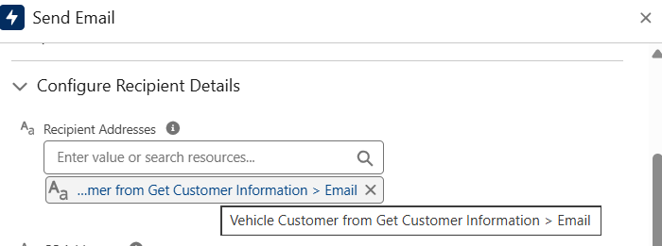
Figure 42: Recipient Addresses of the Send Email action showing the customer email from Get Customer Information
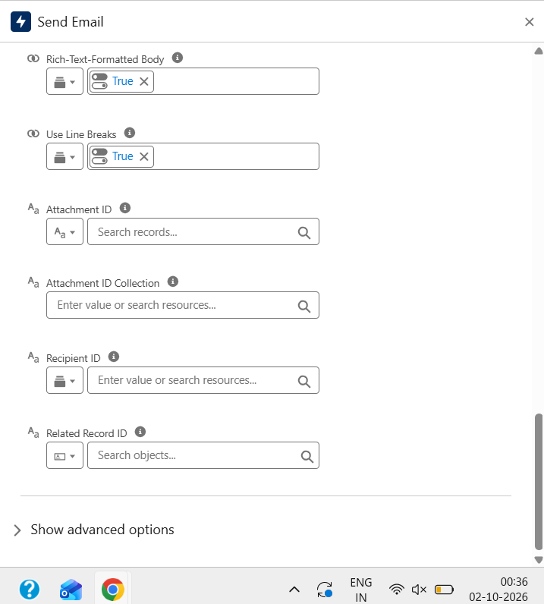
Figure 43: Rich-Text-Formatted Body and Use Line Breaks set to True in Version 2

MileStone 7 :

Create Apex and Trigger Batch Jobs :

Activity 1: Open the Developer Console
Step 1 : Click the gear icon and select Developer Console from the Setup Menu. The screenshot was taken from the Fields & Relationships page of the Vehicle object.
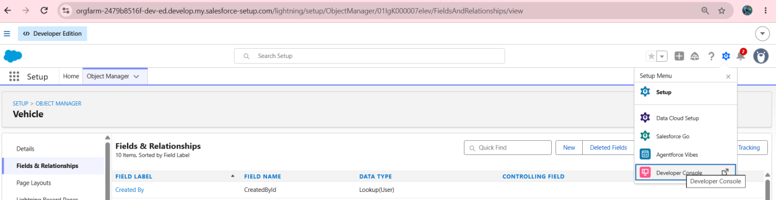
Figure 44: Setup Menu with Developer Console, opened from the Vehicle Fields & Relationships page
Step 2 : In the Developer Console click File, then New. The menu offers Apex Class, Apex Trigger, Visualforce Page, Visualforce Component, Static Resource, Lightning Application, Lightning Component, Lightning Interface, Lightning Event and Lightning Tokens. The tabs for the four Apex files of this project are open in the console.
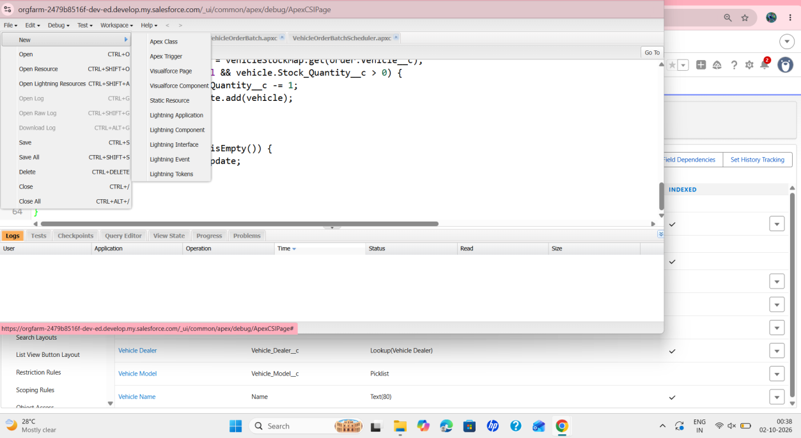
Figure 45: Developer Console File > New menu listing the available file types

Activity 2: Apex Trigger Handler Class
Step 3 : Create an Apex class named VehicleOrderTriggerHandler and write the Apex code. The visible part of the code (up to line 22) is shown below. The remaining lines are [Information not available in the provided screenshots].

public class VehicleOrderTriggerHandler {

public static void handleTrigger(List<Vehicle_Order__c> newOrders, Map<Id, Vehicle_Order__c> oldOrders, Boolean isBefore, Boolean isAfter, Boole...
if (isBefore && (isInsert || isUpdate)) {
preventOrderIfOutOfStock(newOrders);
}

if (isAfter && (isInsert || isUpdate)) {
updateStockOnOrderPlacement(newOrders);
}
}

// Prevent placing an order if stock is zero
private static void preventOrderIfOutOfStock(List<Vehicle_Order__c> orders) {
Set<Id> vehicleIds = new Set<Id>();
for (Vehicle_Order__c order : orders) {
if (order.Vehicle__c != null) {
vehicleIds.add(order.Vehicle__c);
}
}

if (!vehicleIds.isEmpty()) {
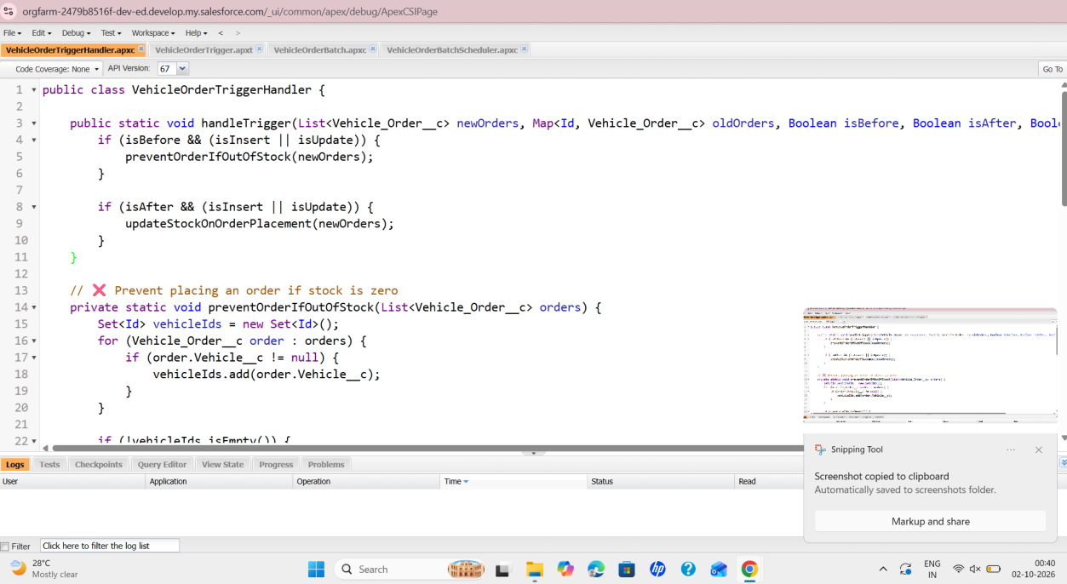
Figure 46: VehicleOrderTriggerHandler class open in the Developer Console
Source Code: VehicleOrderTriggerHandler
public class VehicleOrderTriggerHandler {
public static void handleTrigger(List<Vehicle_Order__c> newOrders, Map<Id, Vehicle_Order__c> oldOrders, Boolean isBefore, Boolean isAfter, Boolean isInsert, Boolean isUpdate) {
if (isBefore) {
if (isInsert || isUpdate) {
preventOrderIfOutOfStock(newOrders);
}
}

if (isAfter) {
if (isInsert || isUpdate) {
updateStockOnOrderPlacement(newOrders);
}
}
}
// Method to prevent orders when the vehicle is out of stock
private static void preventOrderIfOutOfStock(List<Vehicle_Order__c> orders) {
Set<Id> vehicleIds = new Set<Id>();
for (Vehicle_Order__c order : orders) {
if (order.Vehicle__c != null) {
vehicleIds.add(order.Vehicle__c);
}
}
if (!vehicleIds.isEmpty()) {
Map<Id, Vehicle__c> vehicleStockMap = new Map<Id, Vehicle__c>();
for (Vehicle__c vehicle : [SELECT Id, Stock_Quantity__c FROM Vehicle__c WHERE Id IN :vehicleIds]) {
vehicleStockMap.put(vehicle.Id, vehicle);
}
for (Vehicle_Order__c order : orders) {
if (vehicleStockMap.containsKey(order.Vehicle__c)) {
Vehicle__c vehicle = vehicleStockMap.get(order.Vehicle__c);
if (vehicle.Stock_Quantity__c <= 0) {
order.addError('This vehicle is out of stock. Order cannot be placed.');
}
}
}
}
}
// Method to update vehicle stock when an order is placed
private static void updateStockOnOrderPlacement(List<Vehicle_Order__c> orders) {
Set<Id> vehicleIds = new Set<Id>();
for (Vehicle_Order__c order : orders) {
if (order.Vehicle__c != null && order.Status__c == 'Confirmed') {
vehicleIds.add(order.Vehicle__c);
}
}
if (!vehicleIds.isEmpty()) {
Map<Id, Vehicle__c> vehicleStockMap = new Map<Id, Vehicle__c>();
for (Vehicle__c vehicle : [SELECT Id, Stock_Quantity__c FROM Vehicle__c WHERE Id IN :vehicleIds]) {
vehicleStockMap.put(vehicle.Id, vehicle);
}
List<Vehicle__c> vehiclesToUpdate = new List<Vehicle__c>();
for (Vehicle_Order__c order : orders) {
if (vehicleStockMap.containsKey(order.Vehicle__c)) {
Vehicle__c vehicle = vehicleStockMap.get(order.Vehicle__c);
if (vehicle.Stock_Quantity__c > 0) {
vehicle.Stock_Quantity__c -= 1;
vehiclesToUpdate.add(vehicle);
}
}
}
if (!vehiclesToUpdate.isEmpty()) {
update vehiclesToUpdate;
}
}
}
}
Step 4 : A sample Vehicle Order record, O-0001, is shown below. Its fields are Vehicle Order Number, Vehicle Customer, Vehicle, Order Date, Status (Pending) and Assigned Dealer. These are the fields used by the flow and Apex code described in this document.
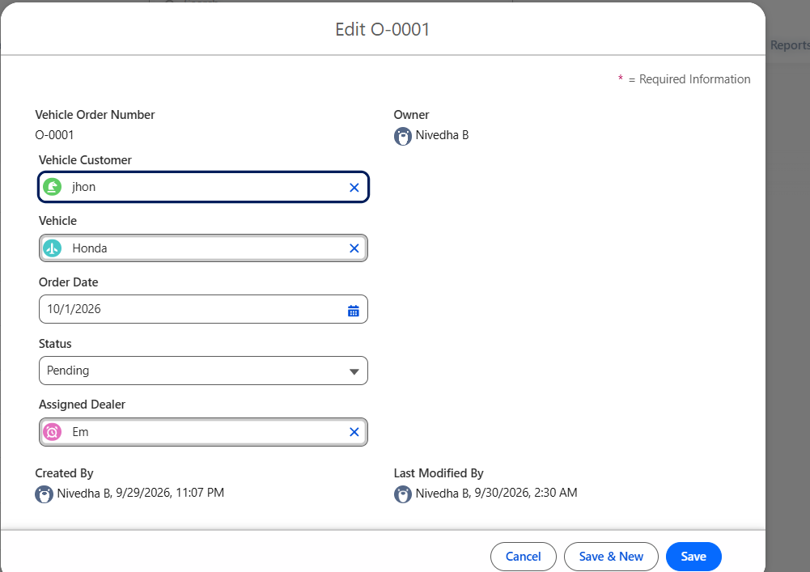
Figure 47: Edit page of Vehicle Order O-0001 showing Status Pending and the Assigned Dealer field

Activity 3: Apex Trigger
Step 5 : In the Developer Console click File, New and select Apex Trigger.
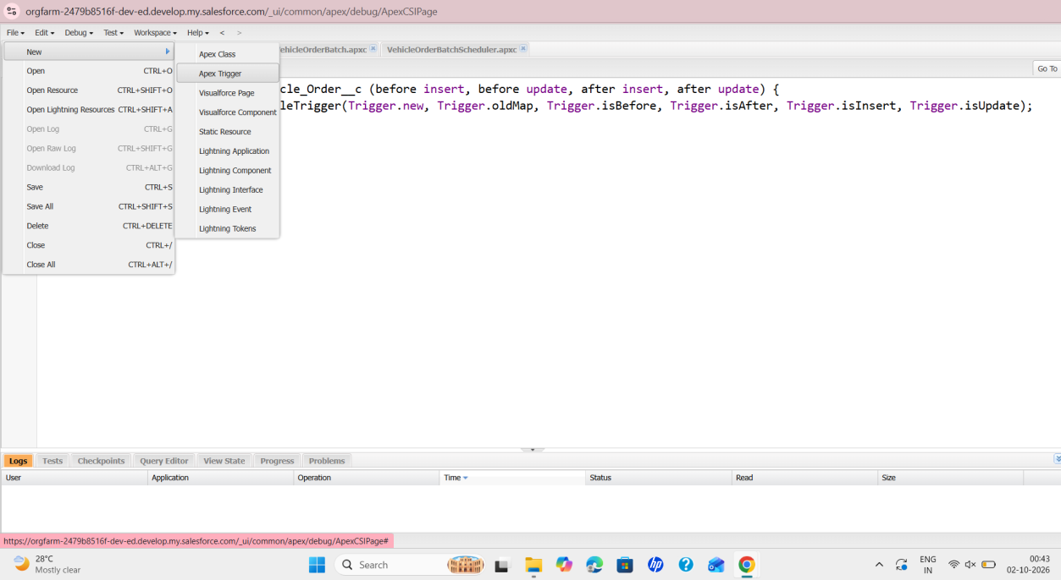
Figure 48: File > New > Apex Trigger option in the Developer Console

Source Code: VehicleOrderTrigger
trigger VehicleOrderTrigger on Vehicle_Order__c (before insert,before update, after insert, after update) {
VehicleOrderTriggerHandler.handleTrigger(Trigger.new, Trigger.oldMap, Trigger.isBefore,Trigger.isAfter, Trigger.isInsert, Trigger.isUpdate);
}

Step 6 : Enter the trigger name VehicleOrderTrigger and select the sObject from the drop-down, then click Submit. The dialog in the screenshot shows Vehicle_Dealer__c in the sObject field.
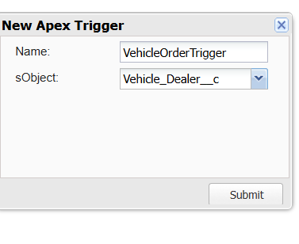
Figure 49: New Apex Trigger dialog with the name VehicleOrderTrigger
Note: the trigger code saved in the editor (Figure 50) is defined on Vehicle_Order__c.
Step 7 : Call the Apex class in the trigger. The trigger code, as saved, is shown below. The end of line 2 is cut off in the screenshot; the full call is visible in Figure 48.

trigger VehicleOrderTrigger on Vehicle_Order__c (before insert, before update, after insert, after update) {
VehicleOrderTriggerHandler.handleTrigger(Trigger.new, Trigger.oldMap, Trigger.isBefore, Trigger.isAfter, Trigger.isInsert, Trigger.isUpdate);
}
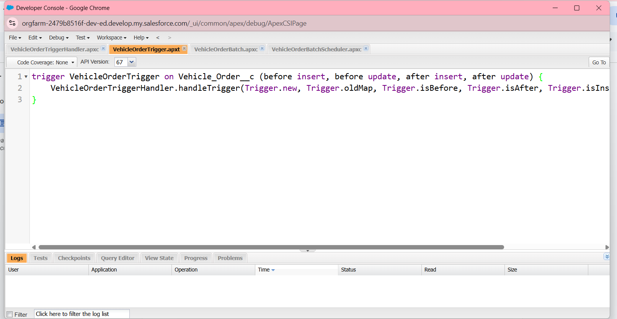
Figure 50: VehicleOrderTrigger on Vehicle_Order__c calling VehicleOrderTriggerHandler

Activity 4: Batch Apex
Step 8 : Create the batch job class. Click File, New, Apex Class and enter the class name VehicleOrderBatch.
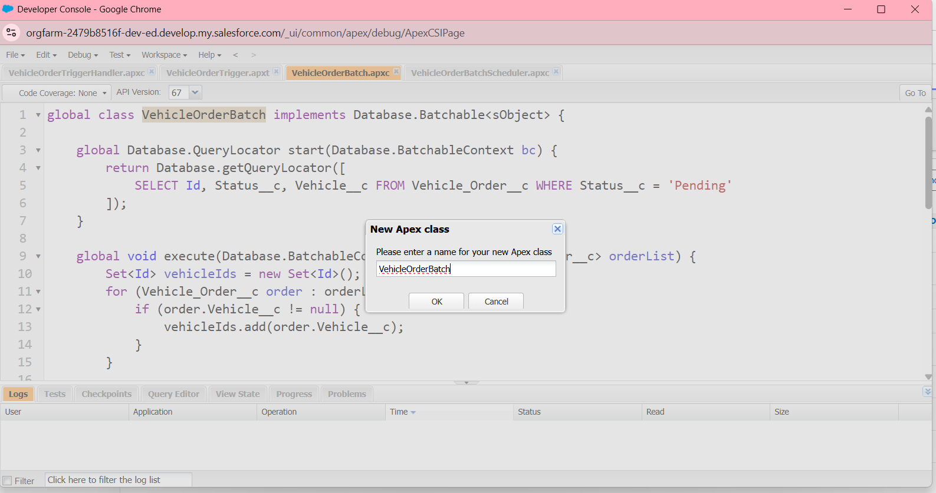
Figure 51: New Apex class dialog with the name VehicleOrderBatch
Source Code:
global class VehicleOrderBatch implements Database.Batchable<sObject> {
global Database.QueryLocator start (Database.BatchableContext bc) {
return Database.getQueryLocator([
SELECT Id, Status_c, Vehicle___c
FROM Vehicle_Order___c
WHERE Status__c
'Pending'
]);
}
global void execute(Database.BatchableContext bc, List<Vehicle_Order_c> orderList) {
Set<Id> vehicleIds = new Set<Id>();
for (Vehicle_Order_c order orderList) {
if (order.Vehicle_c != null) {
vehicleIds.add(order.Vehicle__c);
}
}
if (!vehicleIds.isEmpty()) {
Map<Id, Vehicle___c> vehicleStockMap = new Map<Id, Vehicle___c>();
for (Vehicle_c vehicle: [SELECT Id, Stock Quantity_c FROM Vehicle_c WHERE Id IN vehicleIds]) {
vehicleStockMap.put(vehicle. Id, vehicle);
}
List<Vehicle_Order_c> ordersToUpdate = new List<Vehicle_Order_c>(); List<Vehicle__c> vehiclesToUpdate = new List<Vehicle__c>();
for (Vehicle_Order_c order orderList) {
if (vehicleStockMap.containsKey(order. Vehicle__c)) {
Vehicle_c vehicle = vehicleStockMap.get(order. Vehicle__c);
if (vehicle.Stock_Quantity___c > 0) {
order.Status___c = 'Confirmed';
vehicle.Stock_Quantity___c -= 1;
ordersToUpdate.add(order);
vehiclesToUpdate.add(vehicle);
}
}
}
if (!ordersToUpdate.isEmpty()) {
update ordersToUpdate;
}
if (!vehicles ToUpdate.isEmpty()) {
update vehiclesToUpdate;
}
}
global void finish(Database.BatchableContext bc) {
System.debug('Vehicle order batch job completed.');
}
}

Step 9 : The batch class implements Database.Batchable<sObject>. Its start method queries the Pending orders. The visible part of the code (up to line 15) is shown below. The remaining lines are [Information not available in the provided screenshots].

global class VehicleOrderBatch implements Database.Batchable<sObject> {

global Database.QueryLocator start(Database.BatchableContext bc) {
return Database.getQueryLocator([
SELECT Id, Status__c, Vehicle__c FROM Vehicle_Order__c WHERE Status__c = 'Pending'
]);
}

global void execute(Database.BatchableContext bc, List<Vehicle_Order__c> orderList) {
Set<Id> vehicleIds = new Set<Id>();
for (Vehicle_Order__c order : orderList) {
if (order.Vehicle__c != null) {
vehicleIds.add(order.Vehicle__c);
}
}
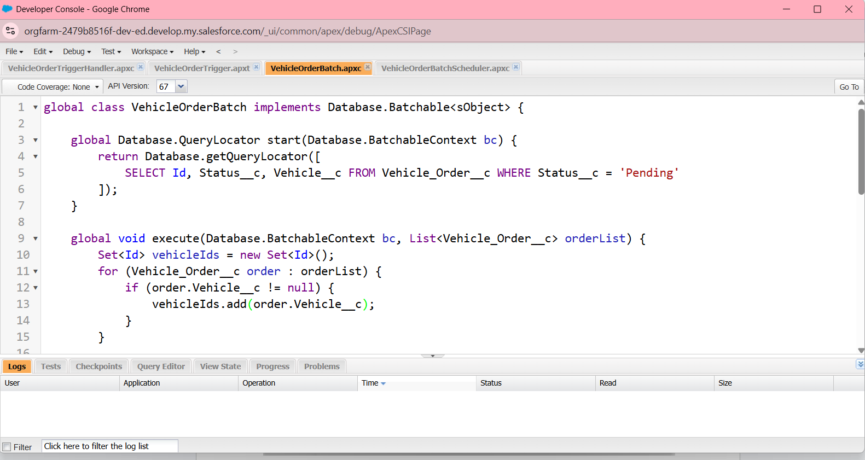
Figure 52: VehicleOrderBatch class code in the Developer Console

Activity 5: Scheduler Class
Step 10 : Create the Schedule class. Click File, New, Apex Class and enter the name VehicleOrderBatchScheduler.
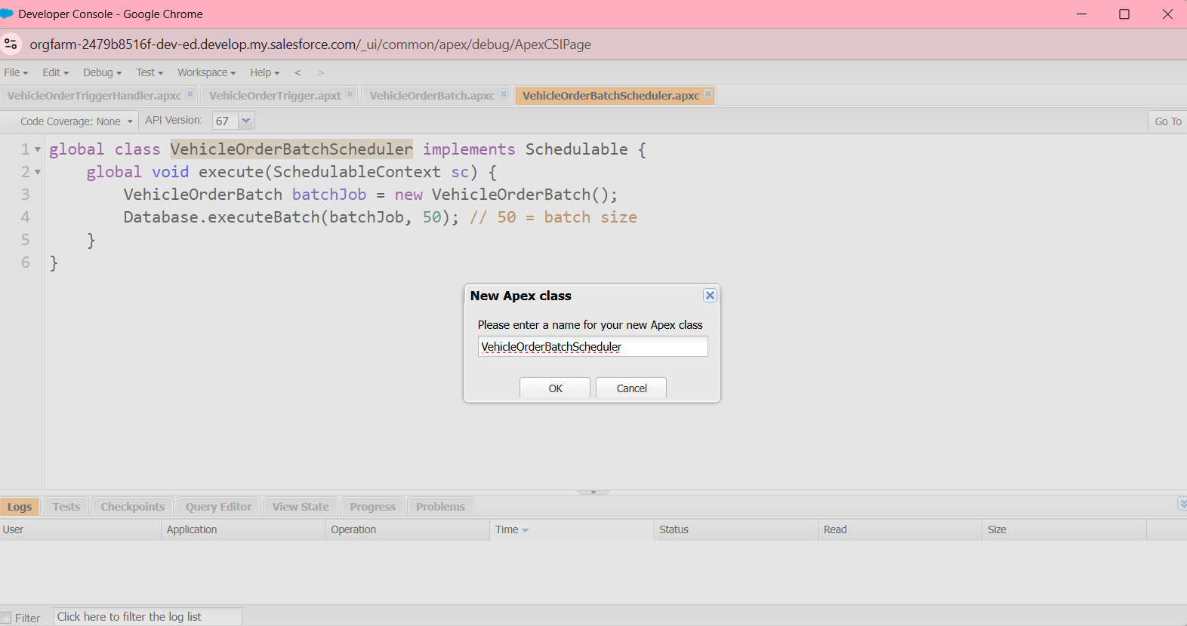
Figure 53: New Apex class dialog with the name VehicleOrderBatchScheduler
Source Code: VehicleOrderBatchScheduler:
global class VehicleOrderBatchScheduler implements Schedulable {
global void execute(SchedulableContext sc) {
VehicleOrderBatch batchJob = new VehicleOrderBatch();
Database.executeBatch(batchJob, 50); // 50 is the batch size
}
}

Step 11 : The schedulable class invokes the batch class with a batch size of 50.

global class VehicleOrderBatchScheduler implements Schedulable {
global void execute(SchedulableContext sc) {
VehicleOrderBatch batchJob = new VehicleOrderBatch();
Database.executeBatch(batchJob, 50); // 50 = batch size
}
}
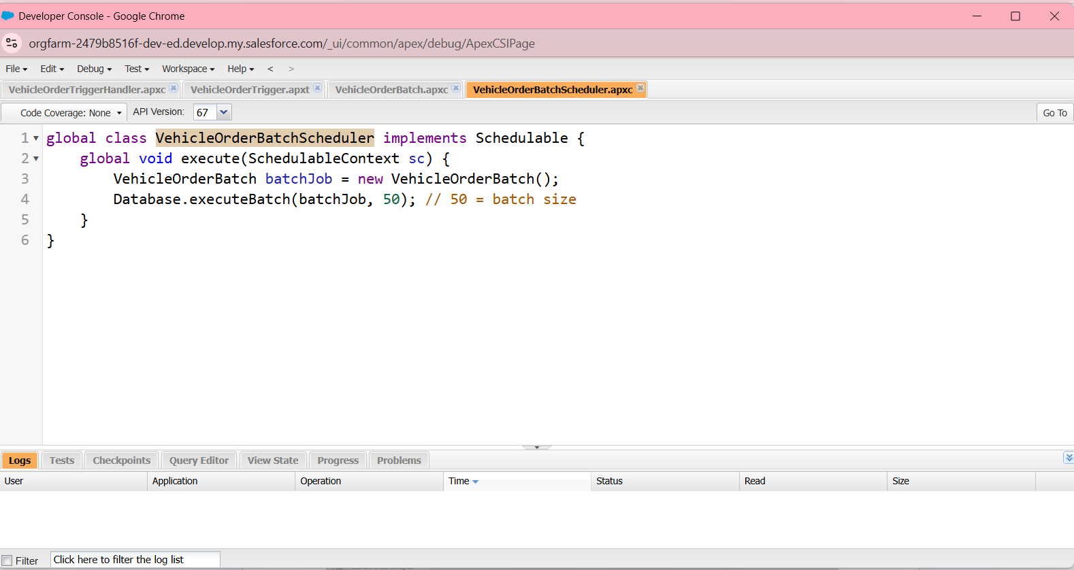
Figure 54: VehicleOrderBatchScheduler class code

Activity 6: Schedule the Batch Job
Step 12 : Open the Execute Anonymous window. In the Developer Console click Debug and select Open Execute Anonymous Window (Ctrl+E).
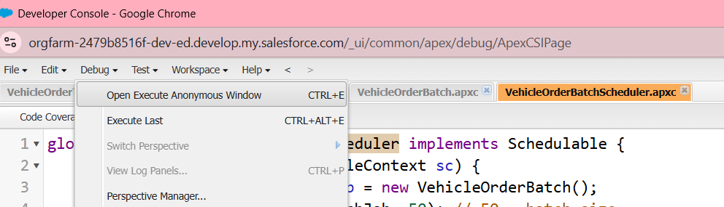
Figure 55: Debug menu with the Open Execute Anonymous Window option
Step 13 : Enter the following code and click Execute. It schedules the job "Daily Vehicle Order Processing" with the cron expression shown (the comment in the code states: runs daily at 12:00 PM).

String cronExp = '0 0 12 * * ?'; // Runs daily at 12:00 PM
System.schedule('Daily Vehicle Order Processing', cronExp, new VehicleOrderBatchScheduler());
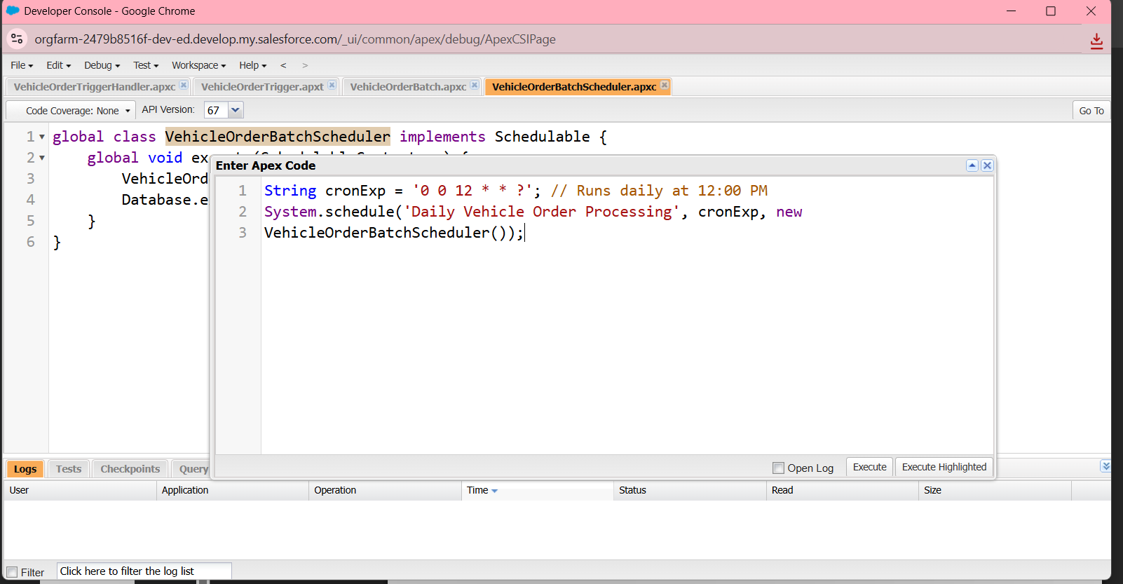
Figure 56: Enter Apex Code window with the cron expression and System.schedule call

Source Code:
String cronExp = '0 0 12 * * ?'; // Runs daily at 12:00 PM
System.schedule('Daily Vehicle Order Processing', cronExp, new VehicleOrderBatchScheduler());

Step 14 : Check where the scheduled job is running. From Setup, search "jobs" in Quick Find and open Scheduled Jobs. The list shows the jobs Daily Inventory Sync and Daily Vehicle Order Processing (type Scheduled Apex, submitted by B. Nivedha). The page also shows that 2% of the scheduled jobs limit is used. The code of the Daily Inventory Sync job is [Information not available in the provided screenshots].
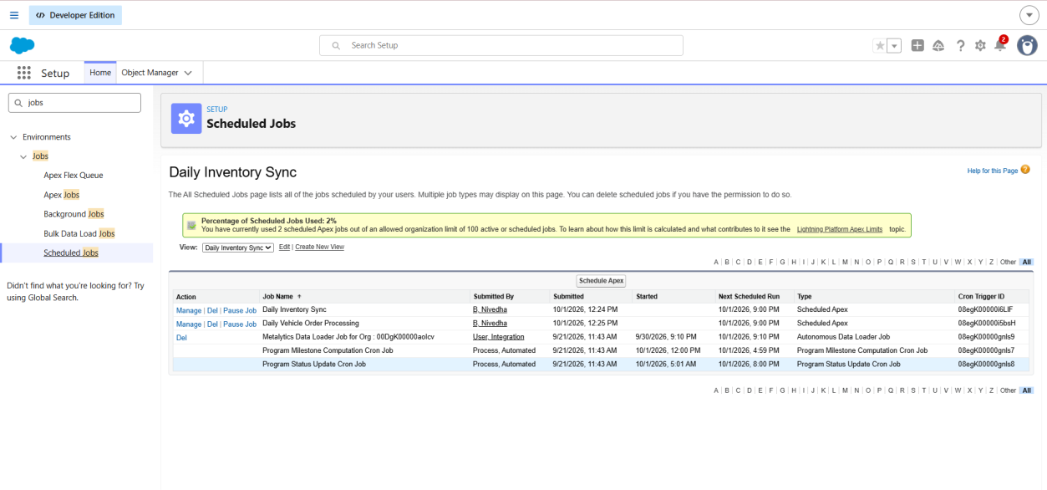
Figure 57: Scheduled Jobs page listing the Daily Vehicle Order Processing job

Final Result / Completion
The screenshots show the following completed work in the Salesforce Developer Edition org:
- A Developer Edition org that is activated and accessible through Setup.
- A Vehicle custom object with Vehicle Model, Stock Quantity and Dealer fields, and tabs for the six Vehicle custom objects.
- The WhatNext Vision Motors Lightning app available to the System Administrator profile.
- The Auto Assign Dealer record-triggered flow, shown as Active.
- The Test Drive Reminder record-triggered flow with a scheduled path that sends an email, shown as Active in Version 2.
- Apex code: VehicleOrderTriggerHandler, VehicleOrderTrigger, VehicleOrderBatch and VehicleOrderBatchScheduler.
- The scheduled job Daily Vehicle Order Processing listed under Scheduled Jobs.
Screenshots showing the outputs of the flows (for example a received reminder email), the stock validation error message.
Thank you

